Motion | Tp(s) | f(rad/s)
Surge | 115 | 0.055
Sway | 125 | 0.05
Heave | 31.4 | 0.2
Roll/pitch | 32.7 | 0.19
Yaw | 7.5 | 0.838
Sensitivity of the responses to the blade azimuth angle and wave direction

Wave: 0.44
Cased 1 All blades are feathered V=38.7, Hs=12, Tp=14.2, wavedir0 and wave dir90
Wave dir=0
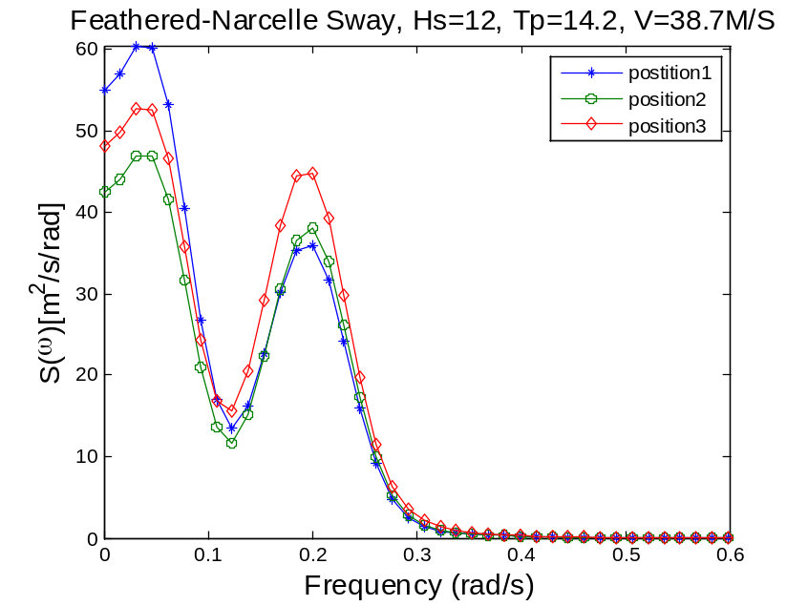
wp1: sway wp2: roll
wave dir=90
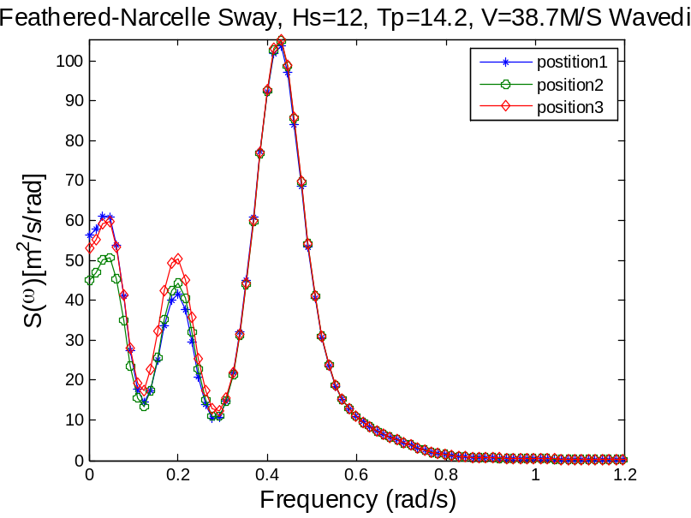
The feathered blades excited wave-induced response
Wave dir=0
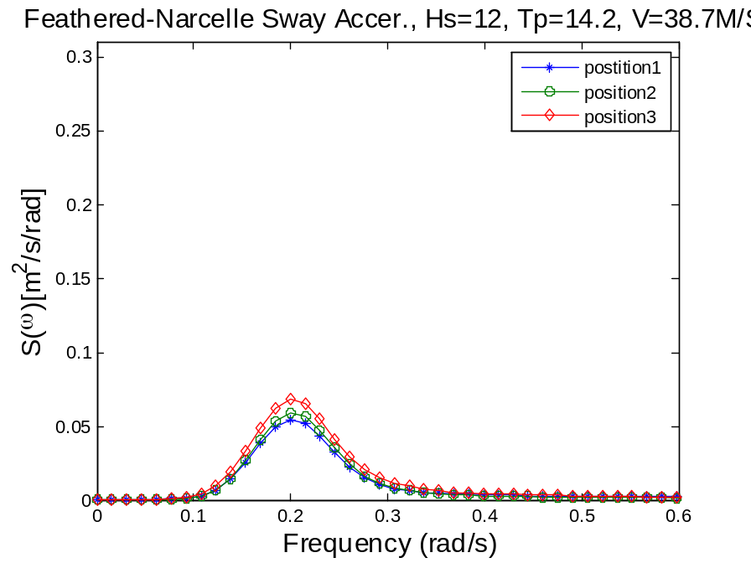
Wave dir=90
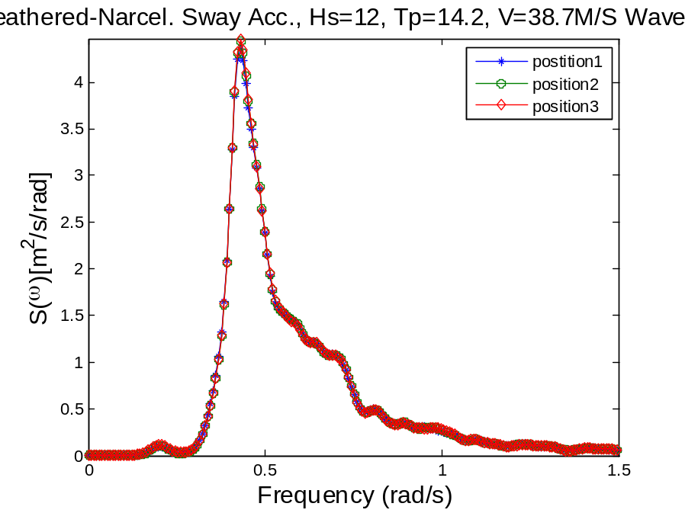
Wp1 roll wp2:wave

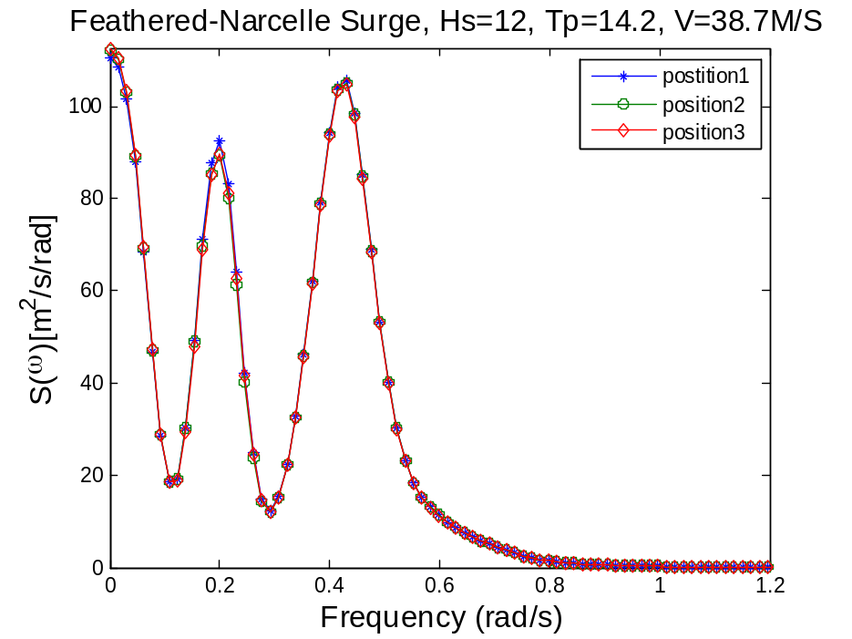
Wave dir=90
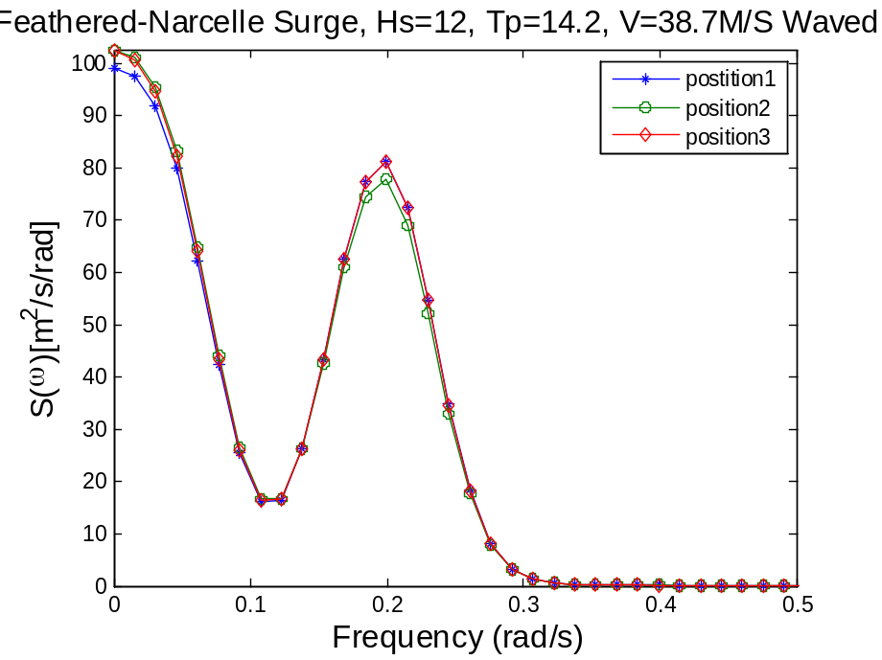
Wave dir90
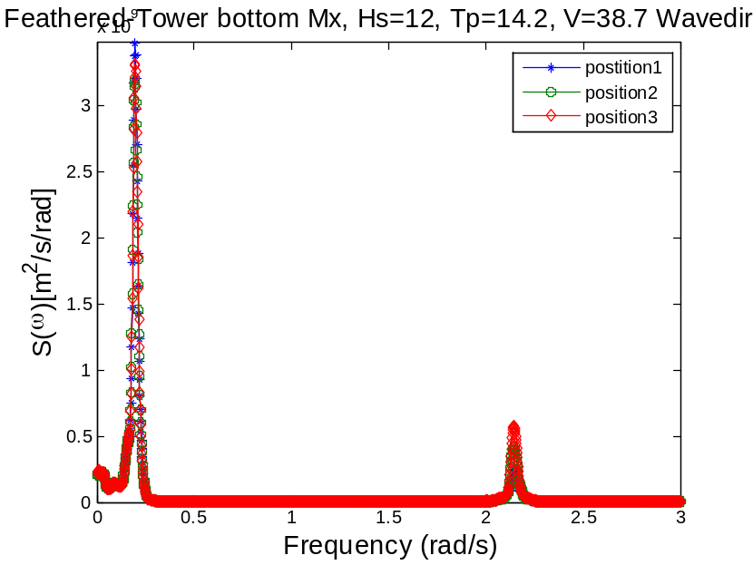
Wp1=0.2, pitch
Wave dir0
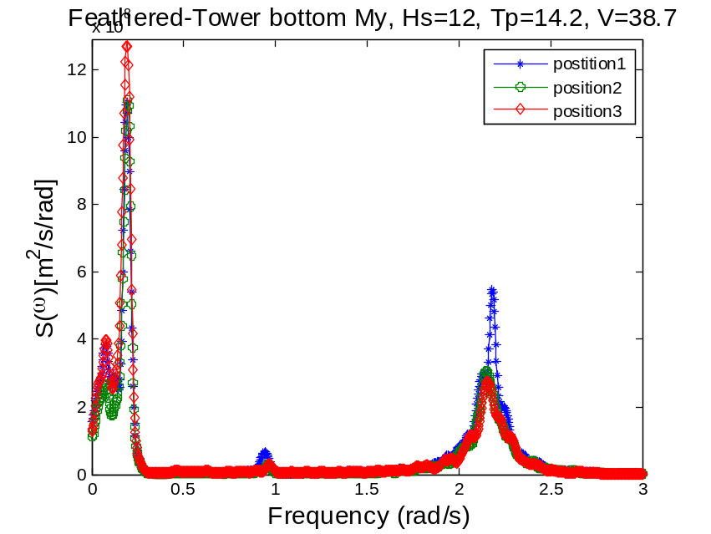
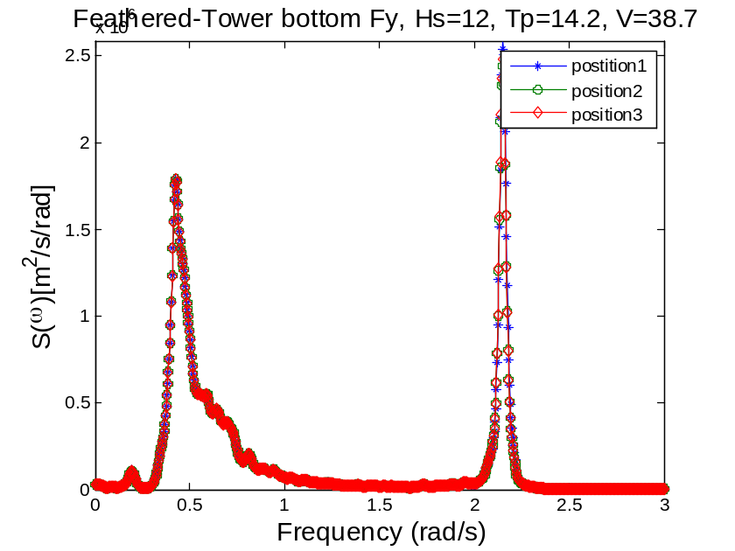

Wave dir0
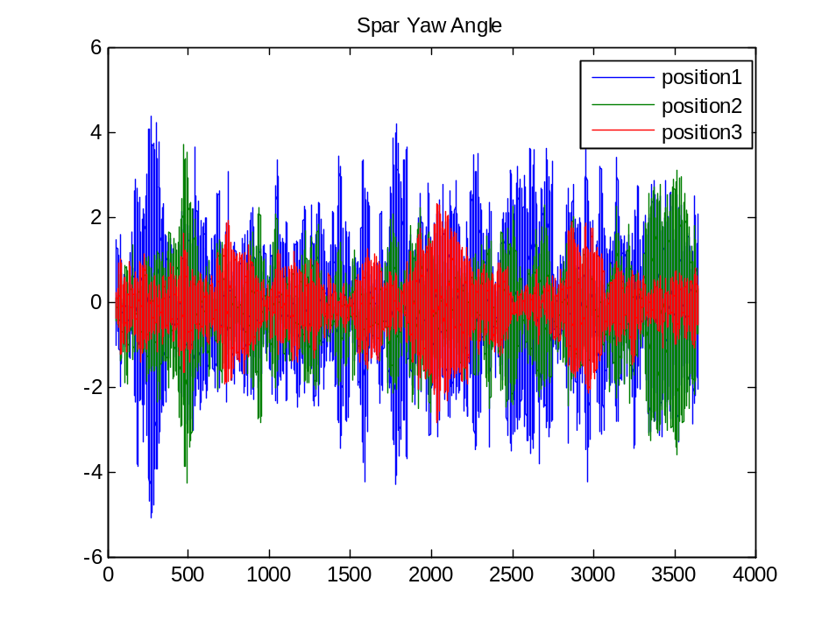
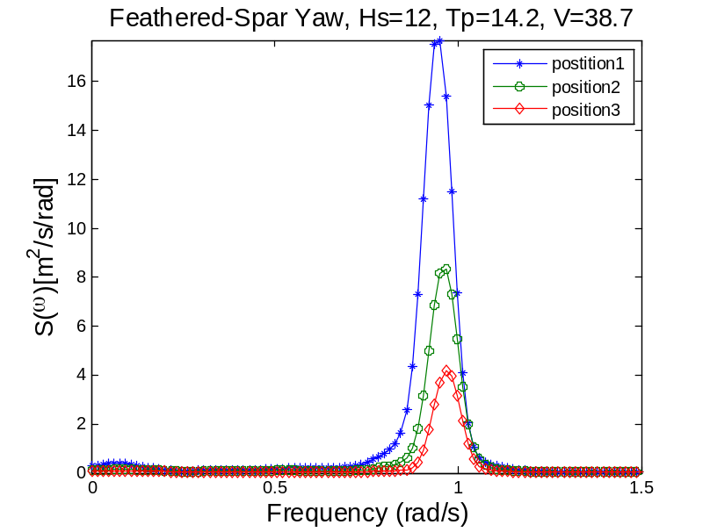
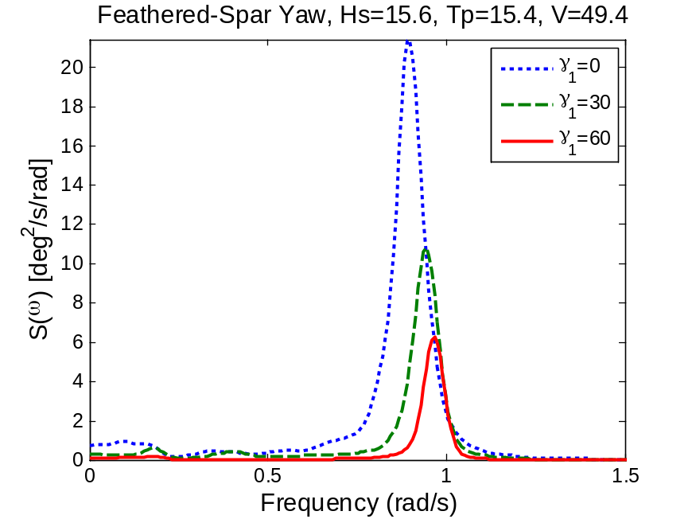
Wave dir90
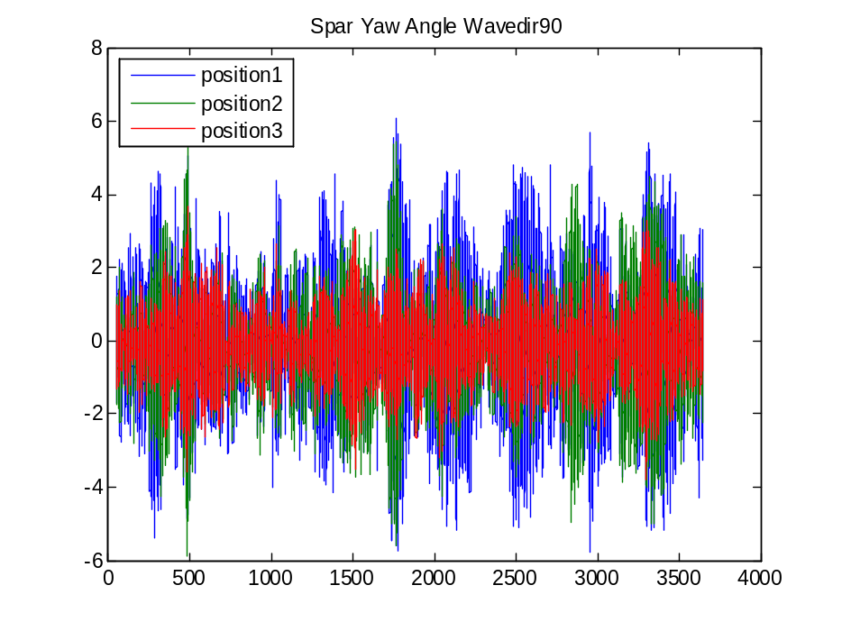
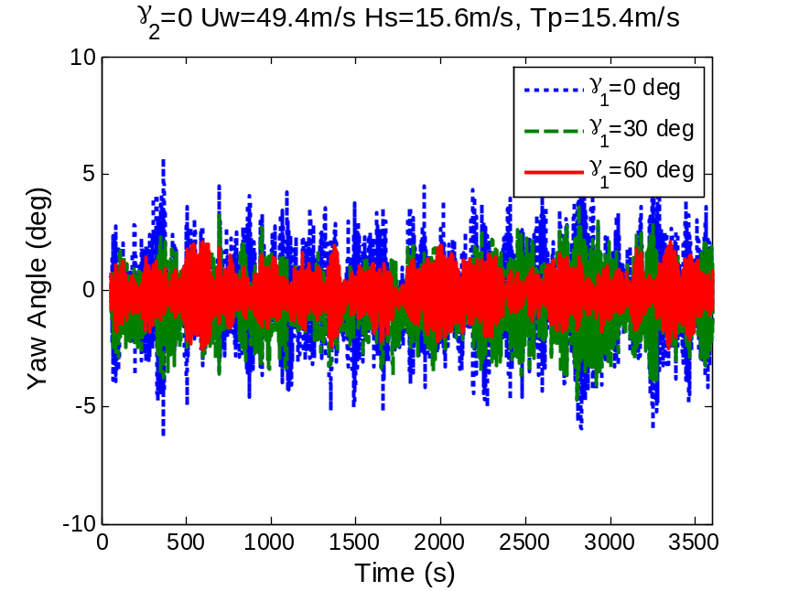
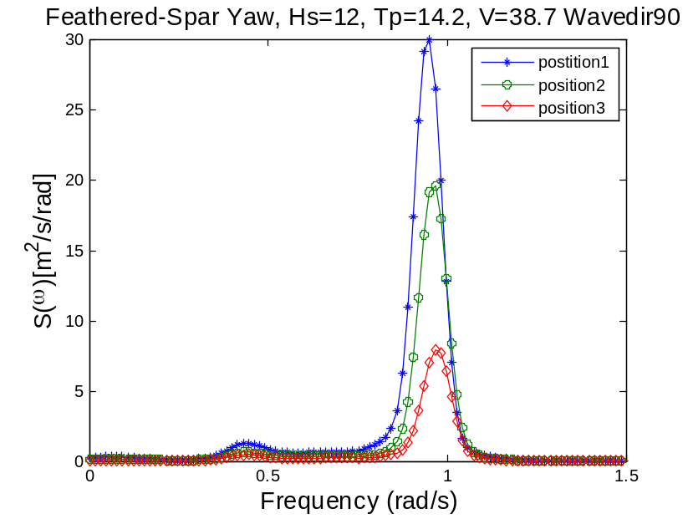
Wave freq. is present in the yaw motion
Wavedir 0
Yaw resonance freq. =0.93, higher than the calculated nat. freq.
No other frequency is present.

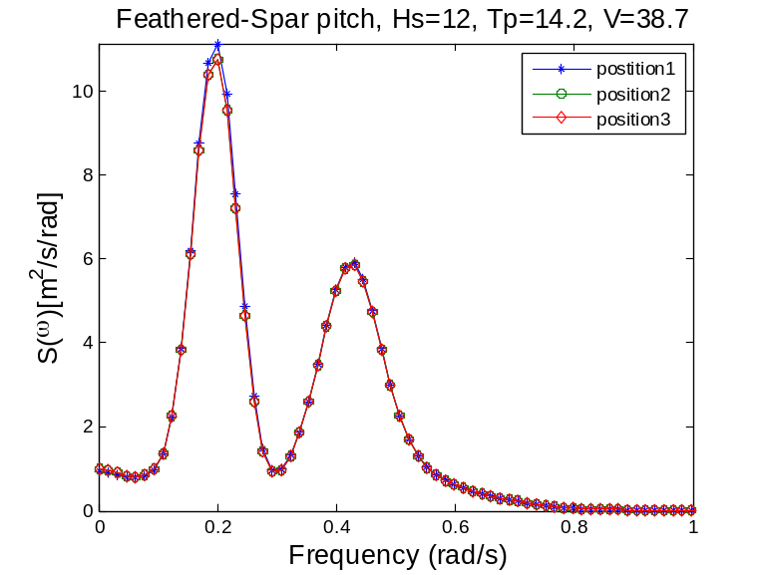
wp1: pitch wp2: wave
wave dir90
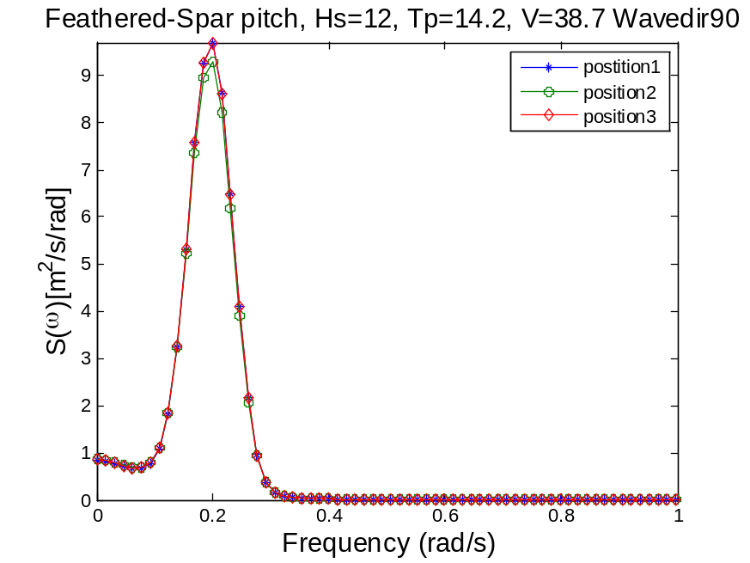
No wave freq. is present in the response
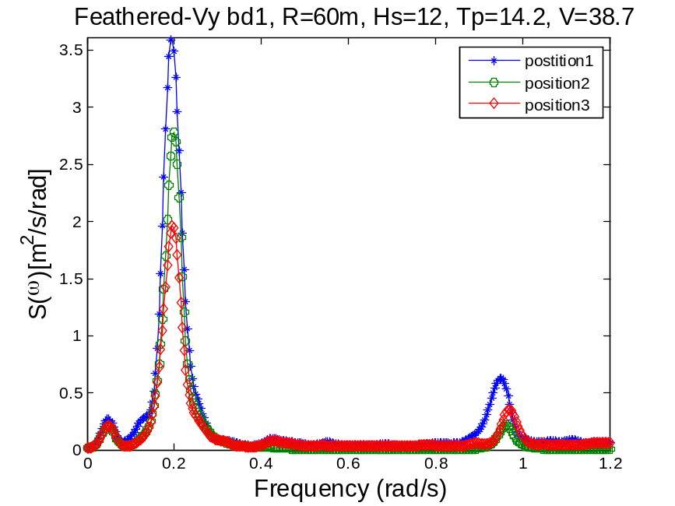
Wp1 pitch wp2 yaw?
Wave dir90
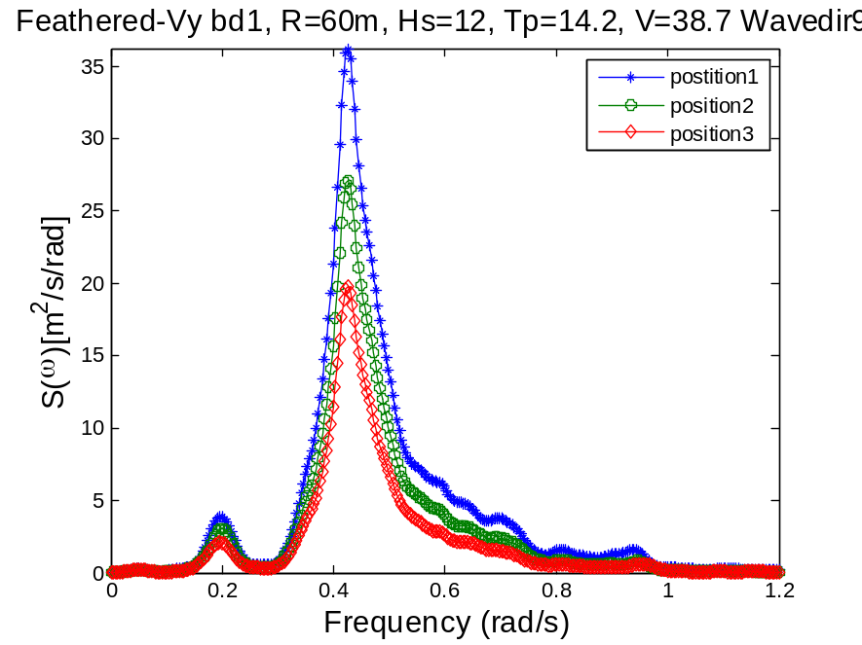
Wp1: pitch wp2: wave freq.
Wave dir0
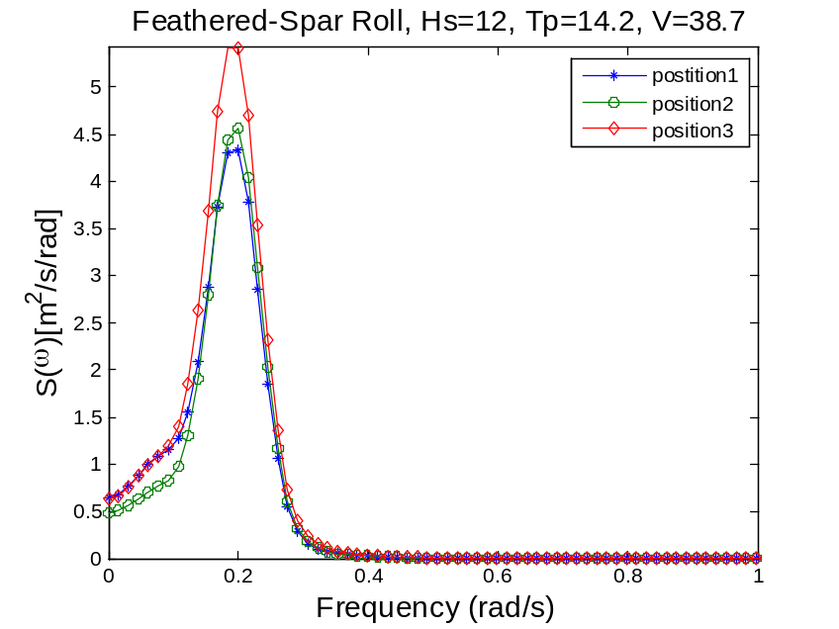
Wave dir90

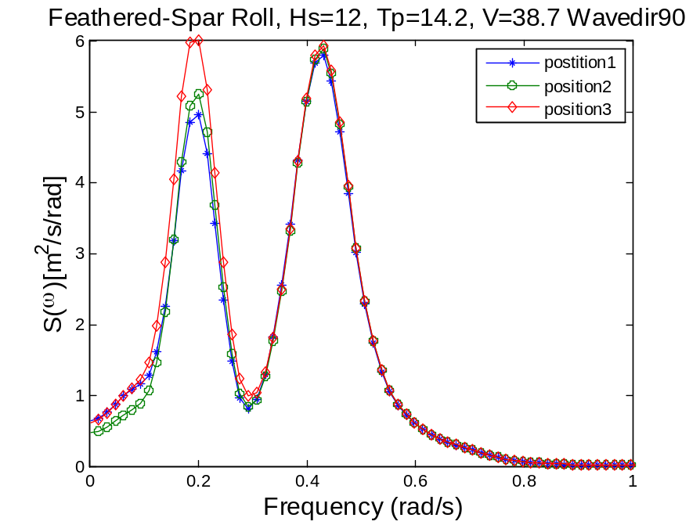
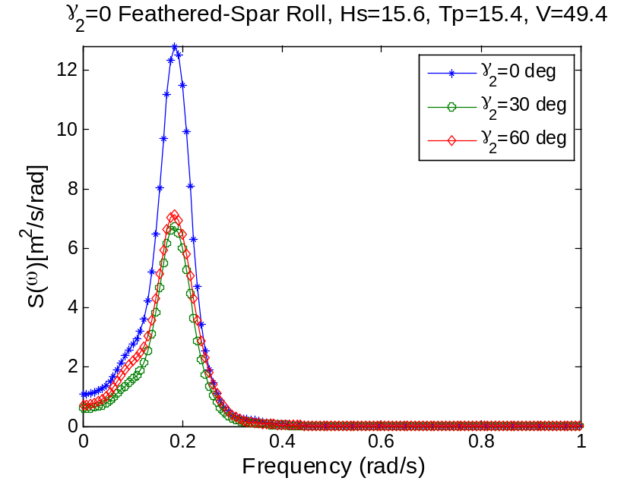

Response Spectrum of the feathered case, wave dir0 and wave dir90
For the feathered cases, most of the response spectrums are sensitive to the wave direction, but insensitive to the azimuth position. The wave resonance response will be unaffected by the change of azimuth angle. Yaw is most susceptible to the blade azimuth. position 1 gives the largest response. No wave-induced peak is present in the yaw response is the direction is 0 but slight wave resonance is observed at 90 deg wave angle. The symmetrical position3 leads to the lowest yaw response. Roll response is slightly sensitive to the azimuth. Azimuth 60 will result in the largest response. No wave-induced peak is present in the roll motion if wave dir=0, but in wave dir=90 there is a large peak. Sway, surge and pitch are insensitive to the azimuth. The tower bottome Mx My and Fy are mainly insensitive to the azimuth. Some of the responses of the blades, edgewise and flapwise are sensitive to the azimuth angle, some are not. This depends on the wave angle. The tip velocity of blade1, Vx and Vy are sensitive to the azimuth.
Case2 Standstill-blade2seized_wind41.7_Hs13.33 Tp14.4 wave dir=0 and wave dir=90 deg
Wave dir. 0
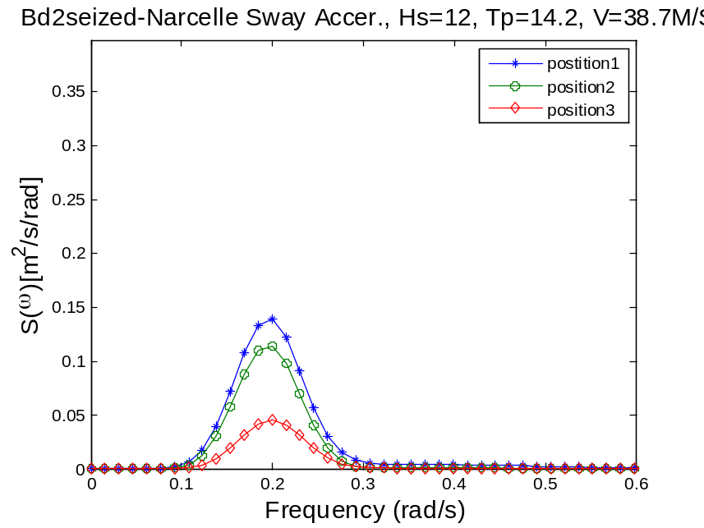
Wp1: roll
Wave dir. 90
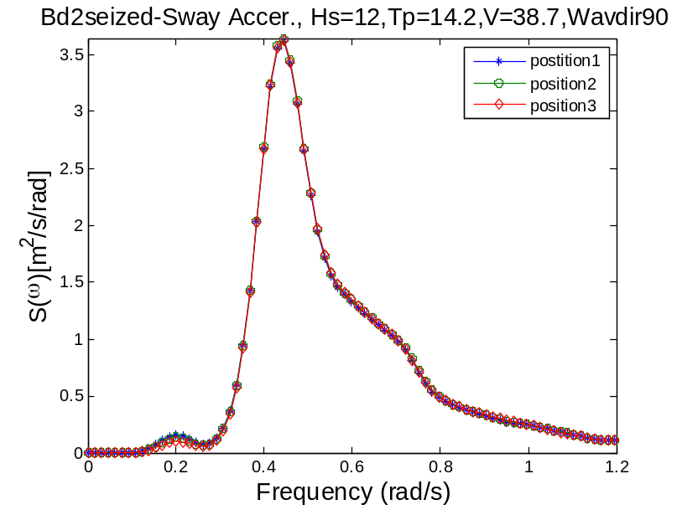
Wave dir0
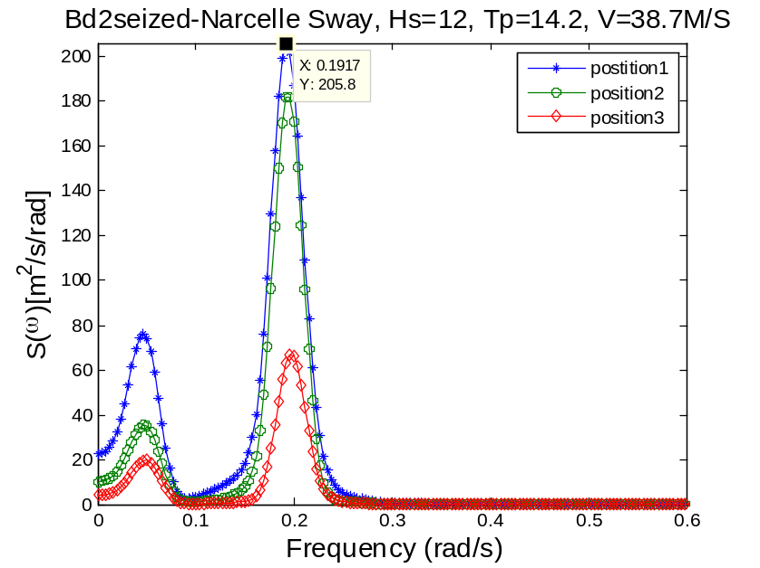

wp1: sway wp2: roll nat. freq.
Wave dir. 90
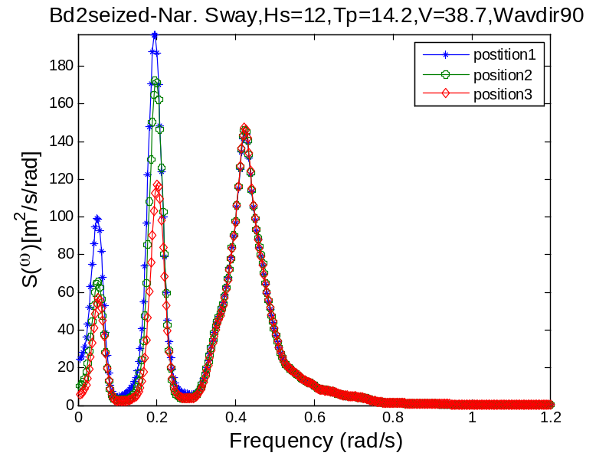
Roll and sway are coupled The symmetrical position3 result in least responses
Wave dir. 0
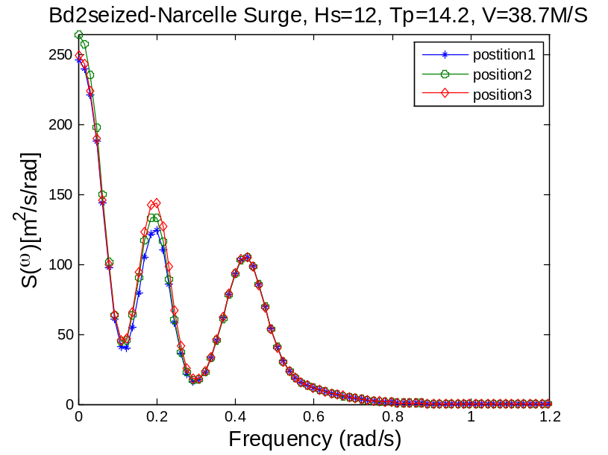
Wave dir. 90
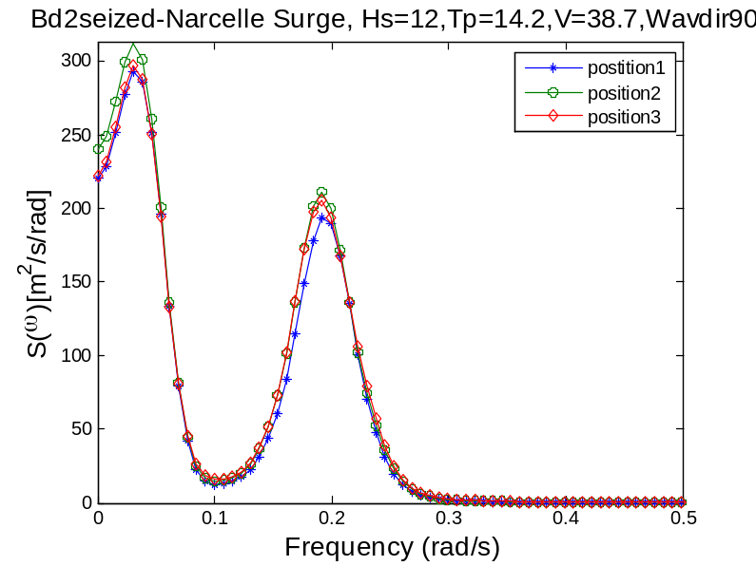

Wave dir. 0

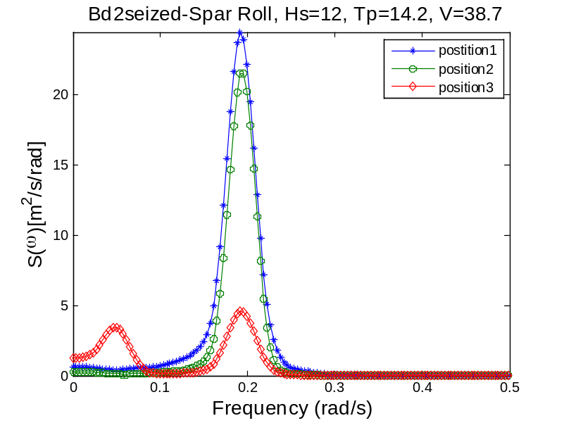
The sway resonance is present in the response of roll motion due to the symmetry position of the blades.
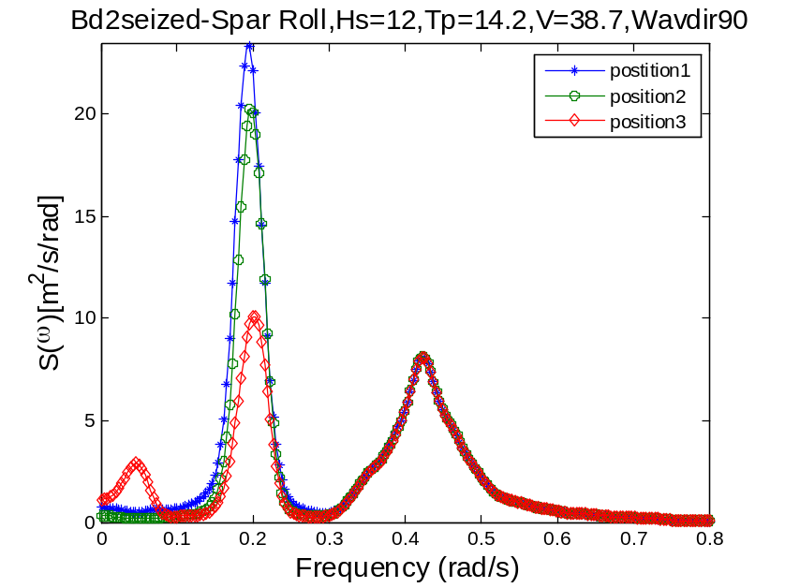
The sway resonant frequency is present in position3. The roll resonant peak of position3 is significantly smaller than that of position1 and 2. The wave frequency part keeps unchanged.
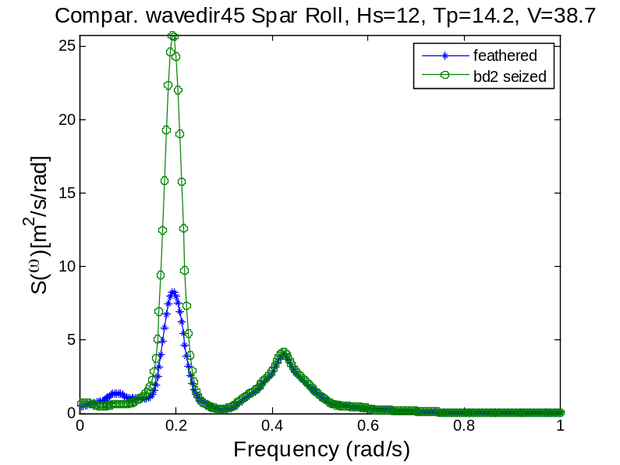

The edgewise response of blade2 has significantly large resonance for position3. Because there is larger aerodynamic loading on it. 1Hz
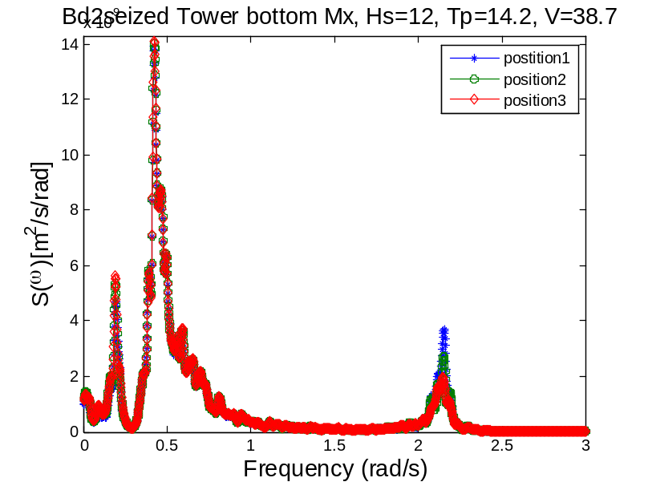
wp1: pitch, wp2: wave freq.
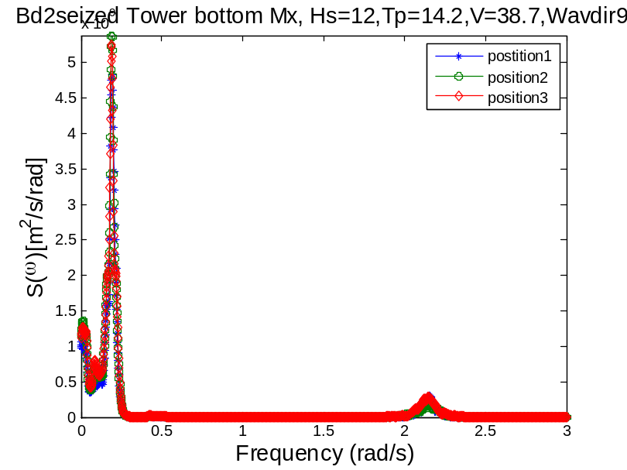
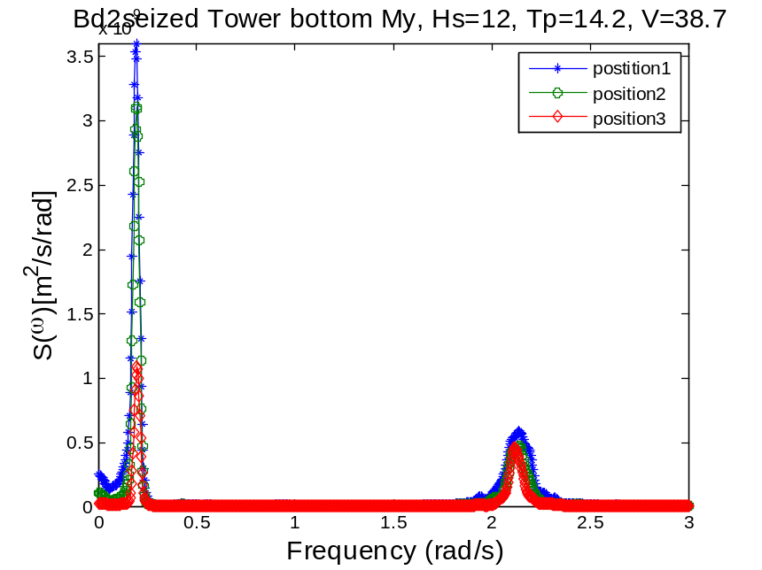
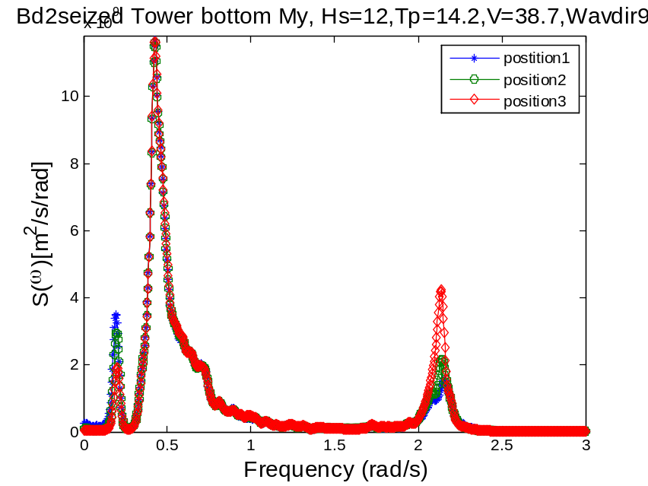
Wp1=0.2 roll

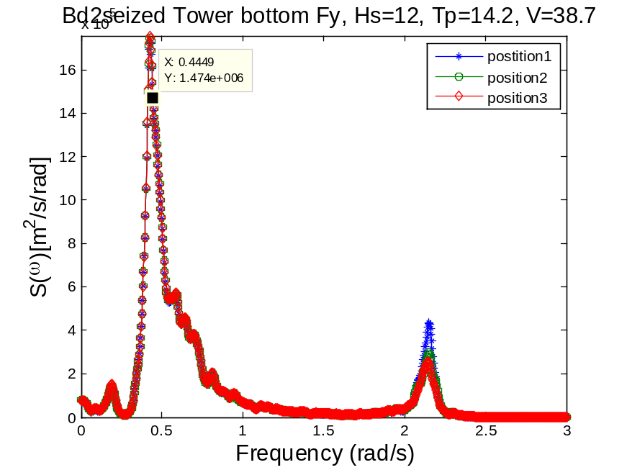
wp1=0.2 pitch, wp2=0.44, wave, wp3=2.15, first tower fore-aft
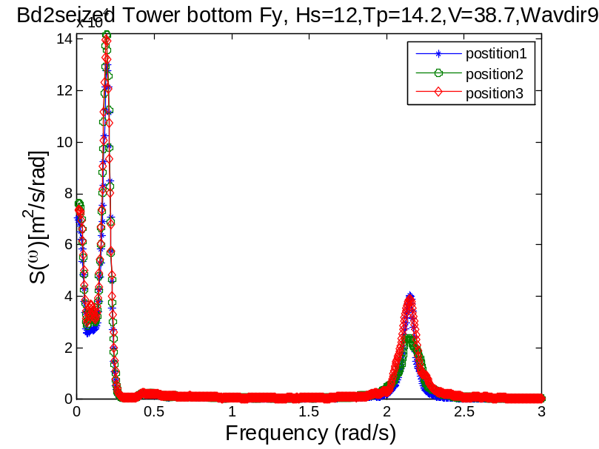

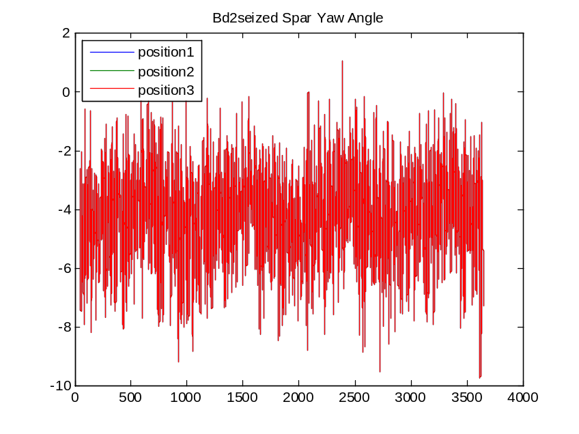
Wave dir0
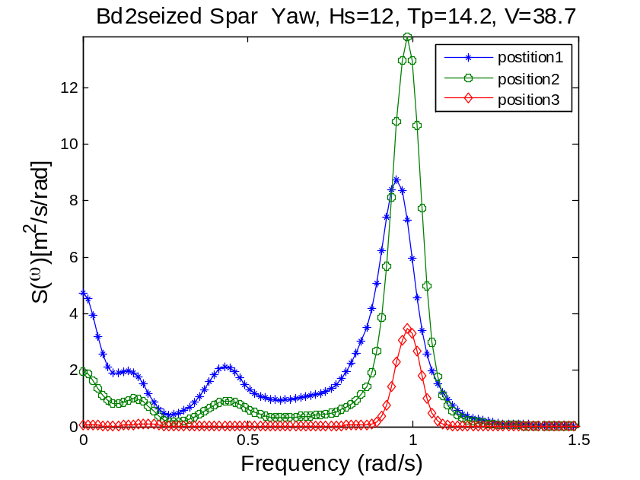
For position1, Wp1=0.15 (roll), wp2=0.44, wp2=0.95(yaw)
Wave dir90
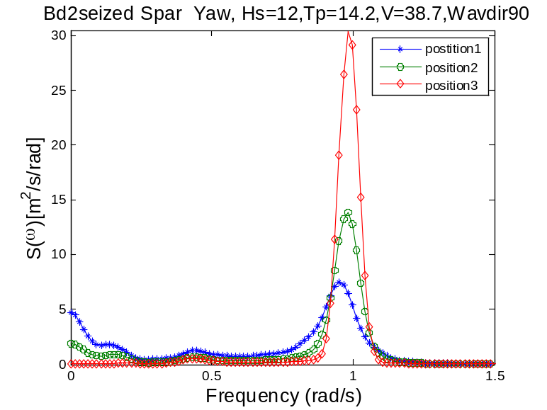
Yaw resonance response is highly sensitive to the azimuth angle of the blade as well as the wave direction. The wave resonant response is largely damped out by the feathered blades 1 and 2.
Wave dir0
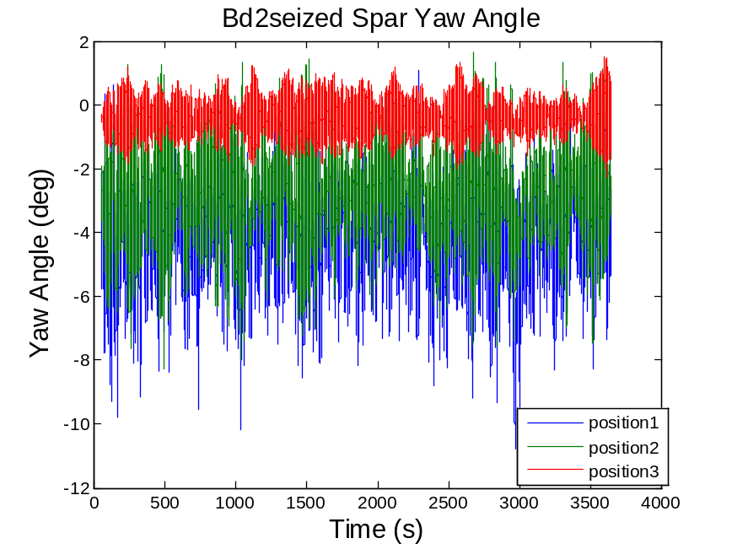
When blade2 is seized, wave-induced response is present in the yaw spectrum of postion3, not in position1 and 2. Since aerodynamic damping of position 2 is largest due to the relative out-of-plane motion of the blade2.
Wave dir90
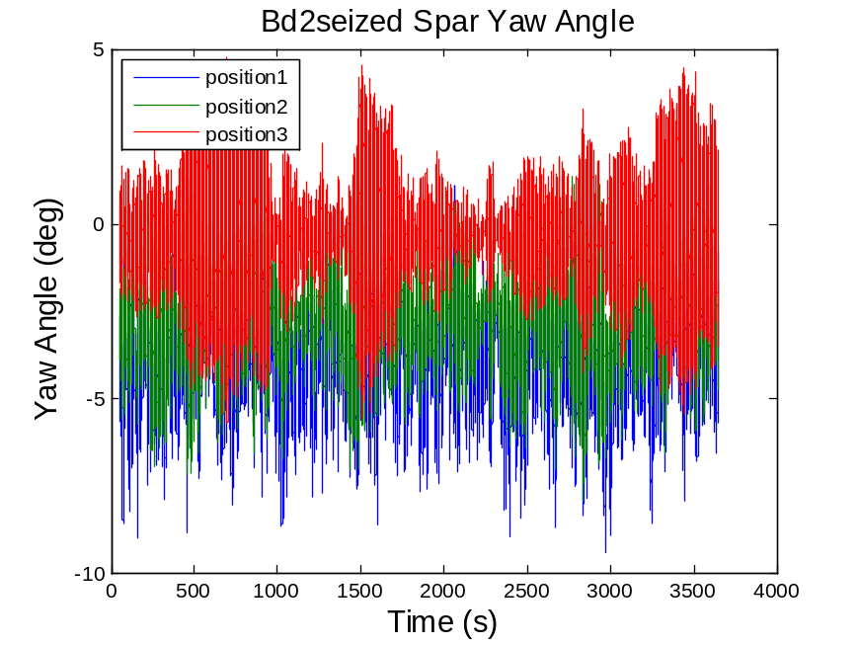
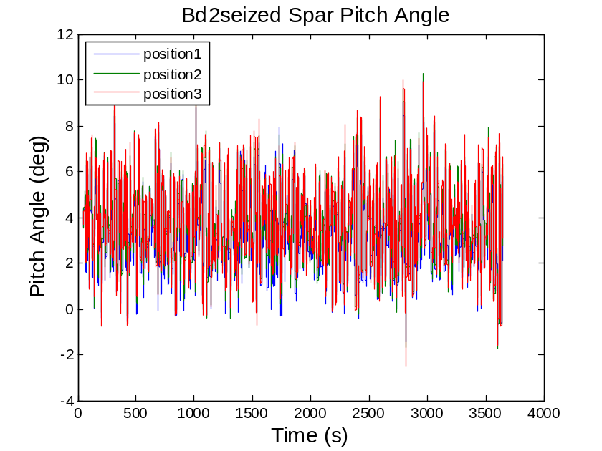
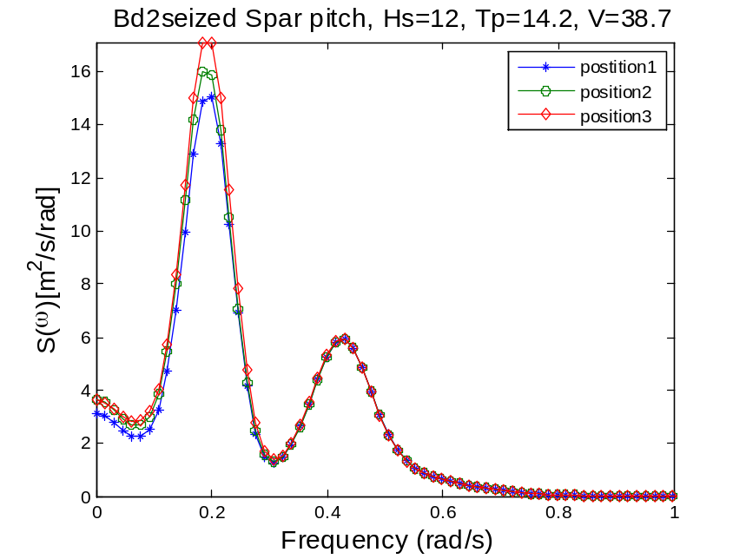
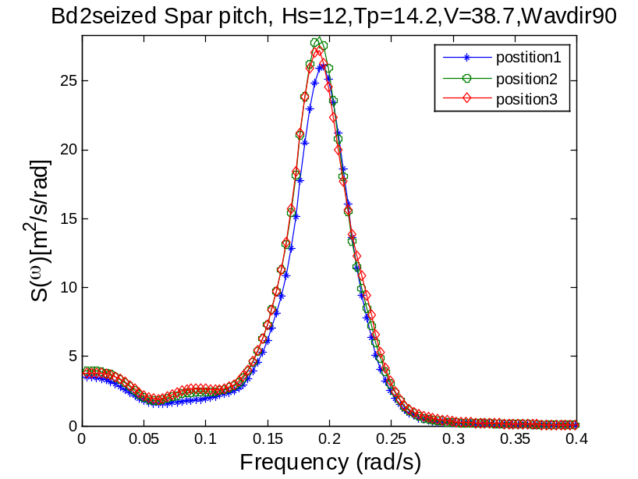
The pitch spectrum is least sensitive to the azimuth position.
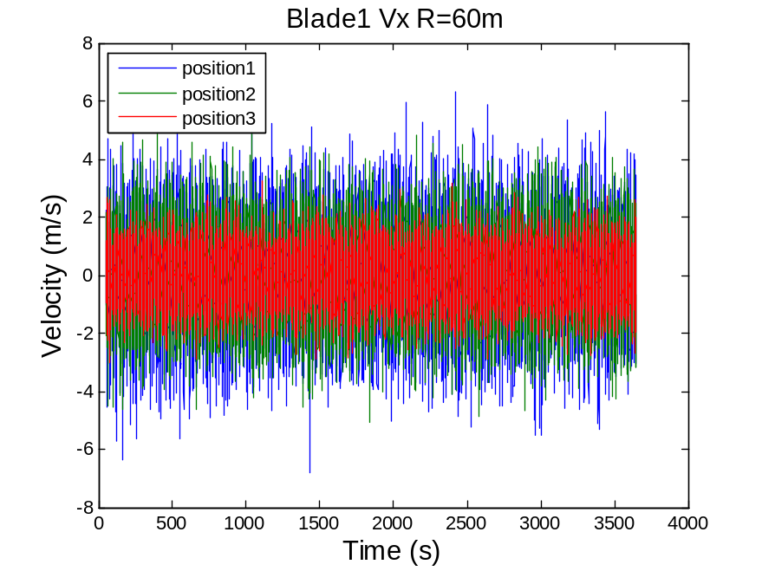
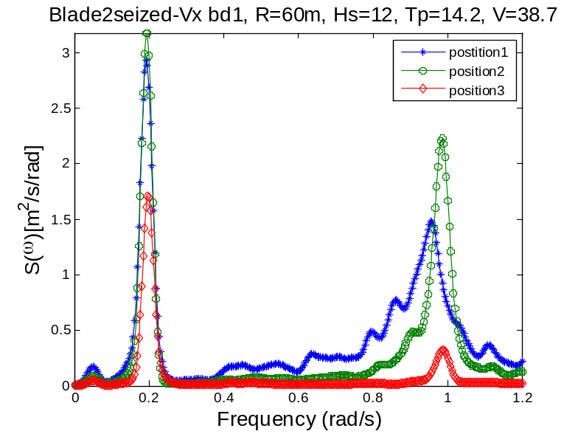
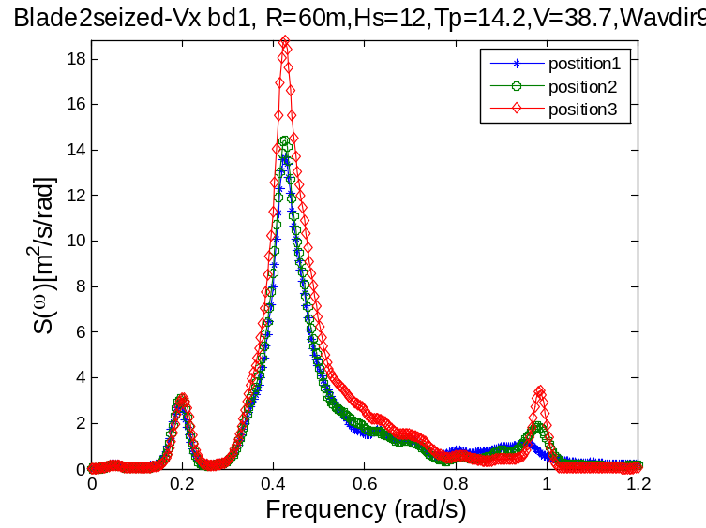

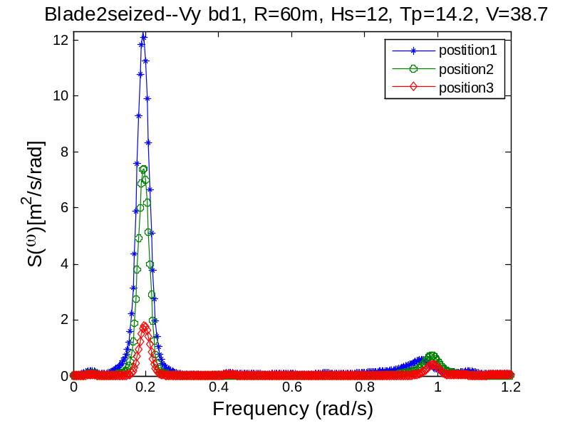
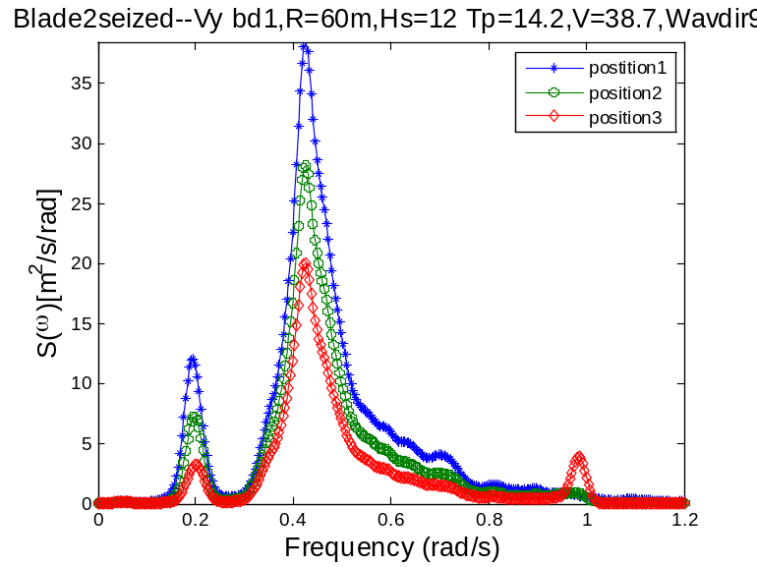
Response Spectrum of the blade2seized case
For the fault cases (blade2 seized), Roll and Yaw are always very sensitive to the azimuth at different wave directions. The roll resonant peak of azimuth 60 is significantly smaller than that of azimuth 0 and 30 and there appears a sway-resonant frequency in the response spectrum. The wave frequency part keeps unchanged with different azimuth. Nacelle sway acceleration and displacement is very sensitive to the azimuth angle at wave direction 0 deg but quite insensitive at wave direction 90. The out of plane and in-plane tip speed of blade1 is also sensitive to the azimuth angle. Pitch and Surge are always less sensitive to the azimuth regardless of the wave direction.
The tower bottom bending moment Mx is sensitive to the azimuth at wave direction 0 deg and insensitive at wave direction 90 deg. similar observation is made for Fy which is in the same direction of Mx. Azimuth 0 and 30 usually have similar response which differ from Azimuth 60’s. The tower bottom bending moment My is sensitive to the azimuth at different wave directions.
Blade root bending moment and velocity tip speed velocity Vx and Vy are sensitive to the azimuth.
Case3 Standstill-blade123seized_wind41.7_Hs13.33 Tp14.4 wave dir=0 and wave dir=90 deg
Wavedir=0
Nacelle sway
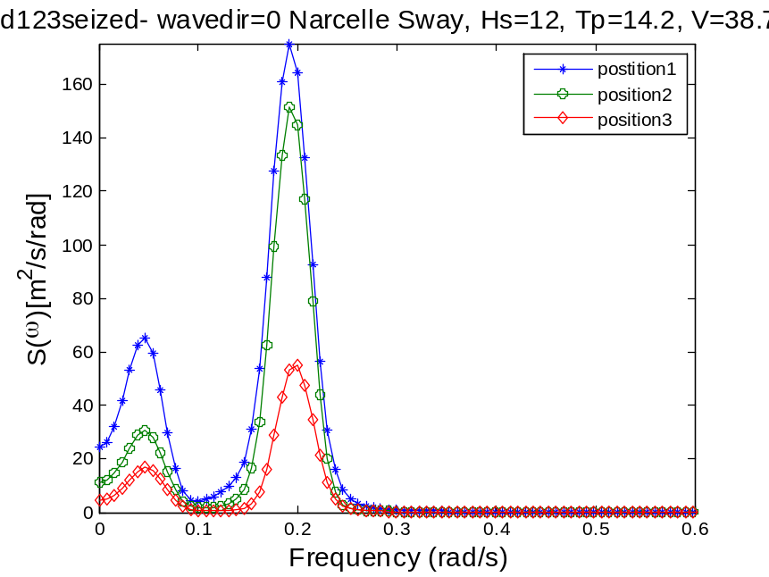
If the wave and wind is collinear, it is the wind loads that primarily affect the sway motion.
Wavedir=0 leads to large discrepancy.
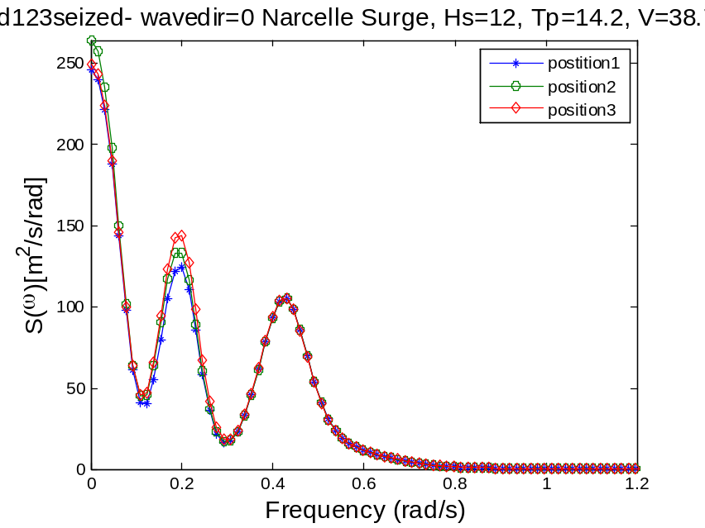
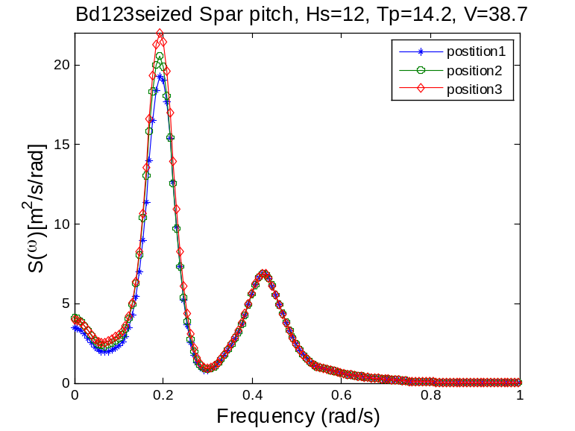
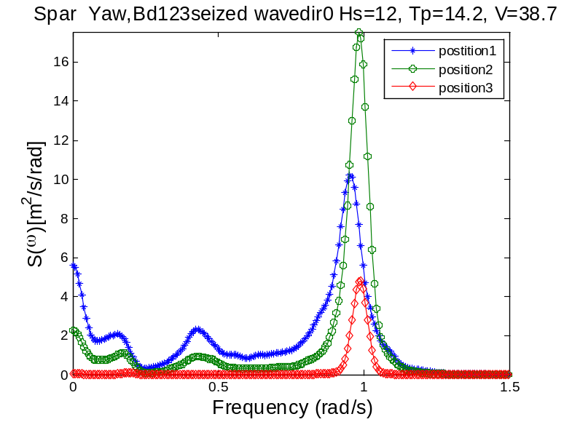
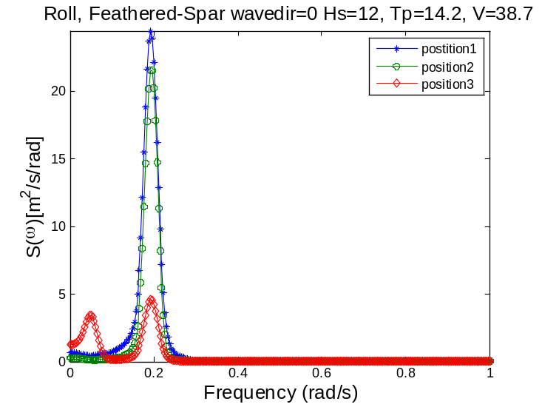

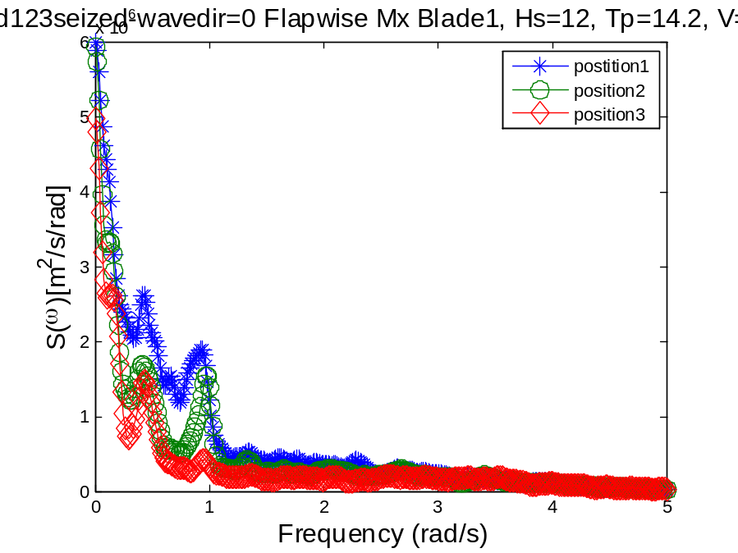
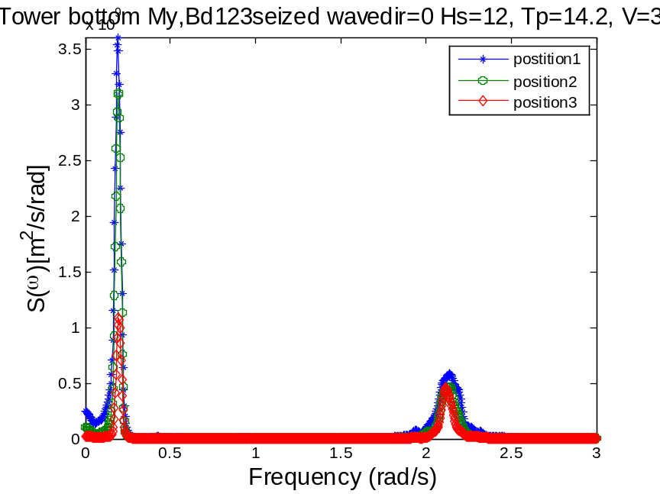
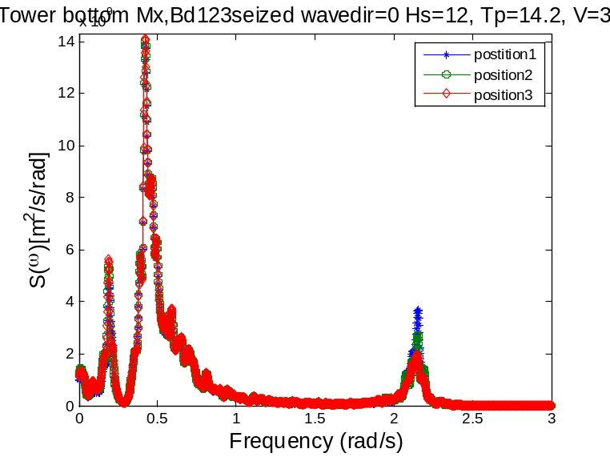
Wavedir=90
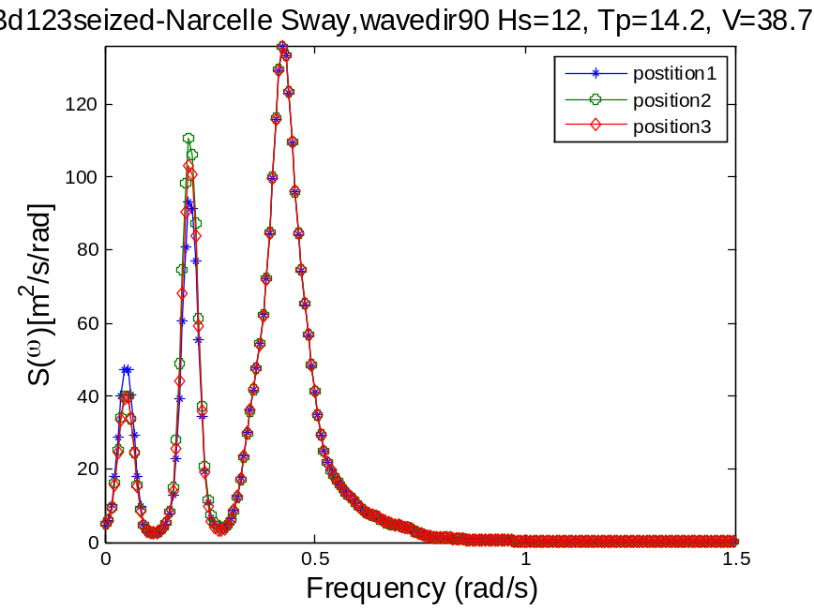
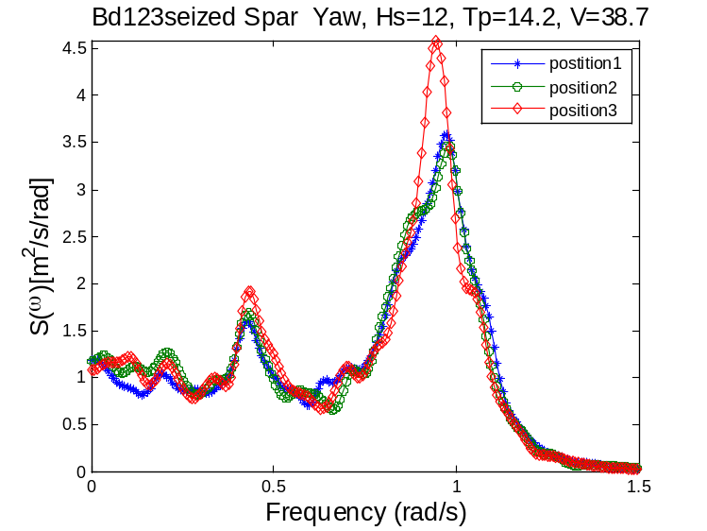
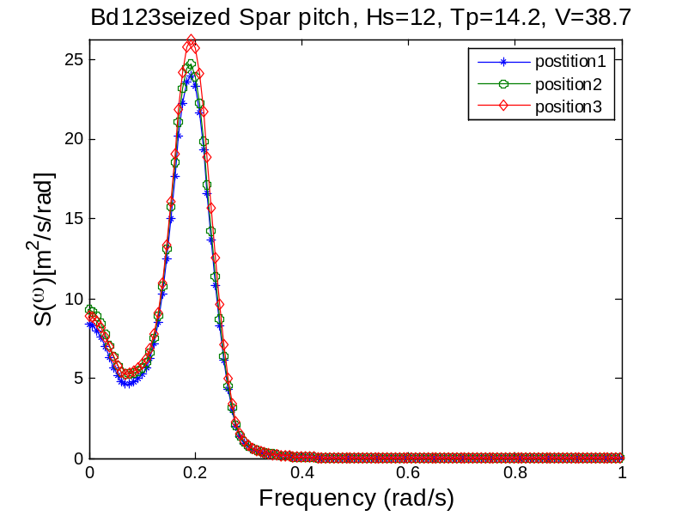
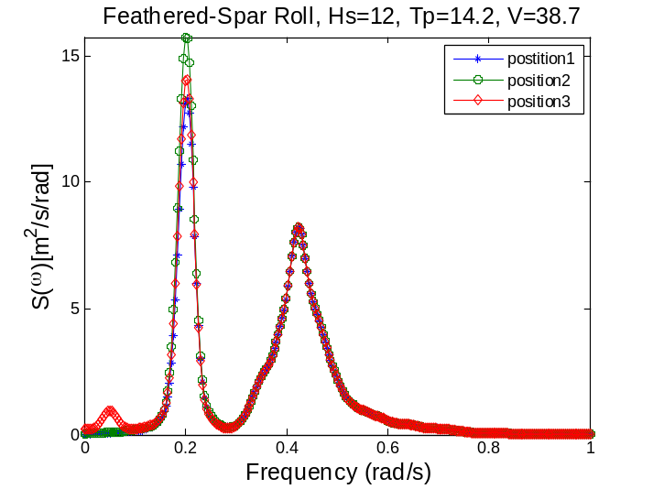
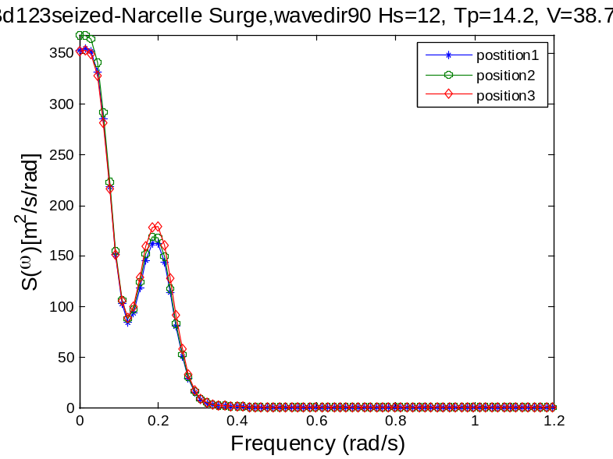
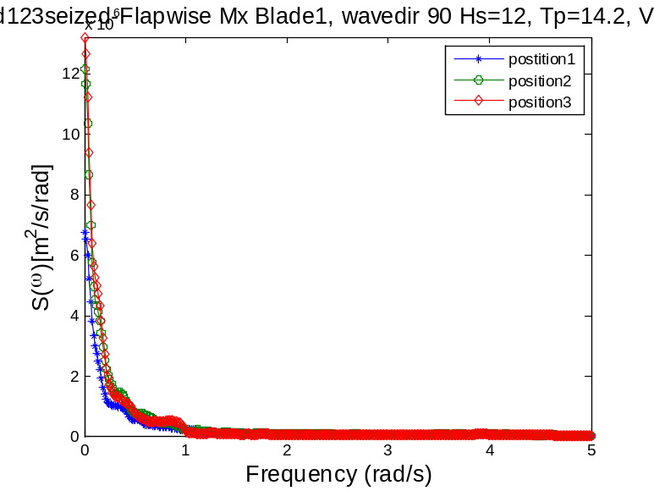
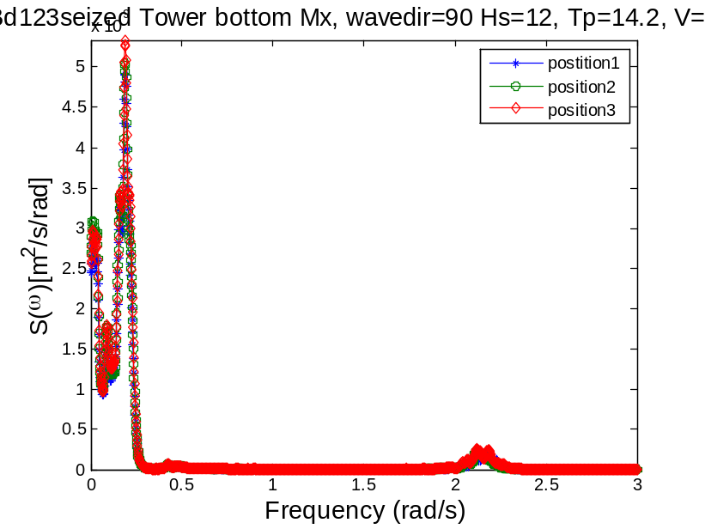
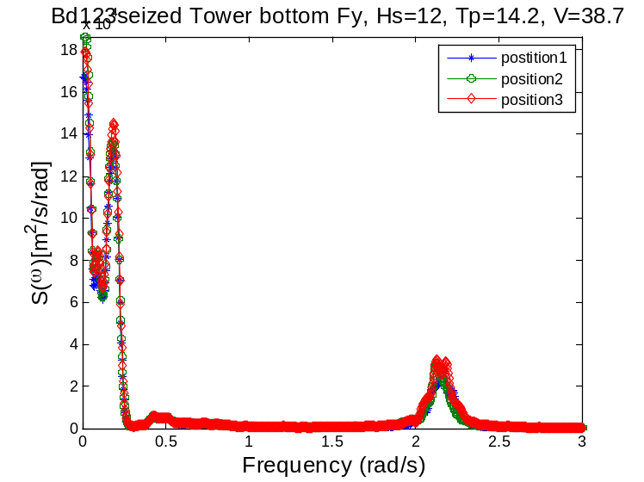
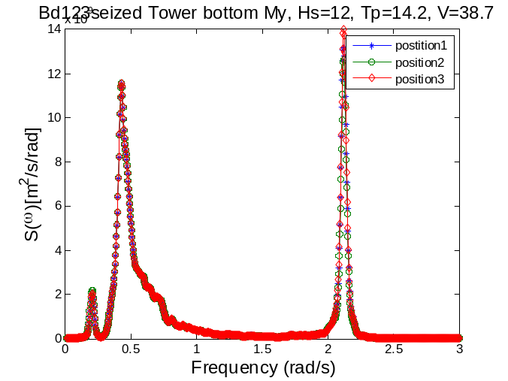
Response Statistics: extremes, mean values and STD
Sway
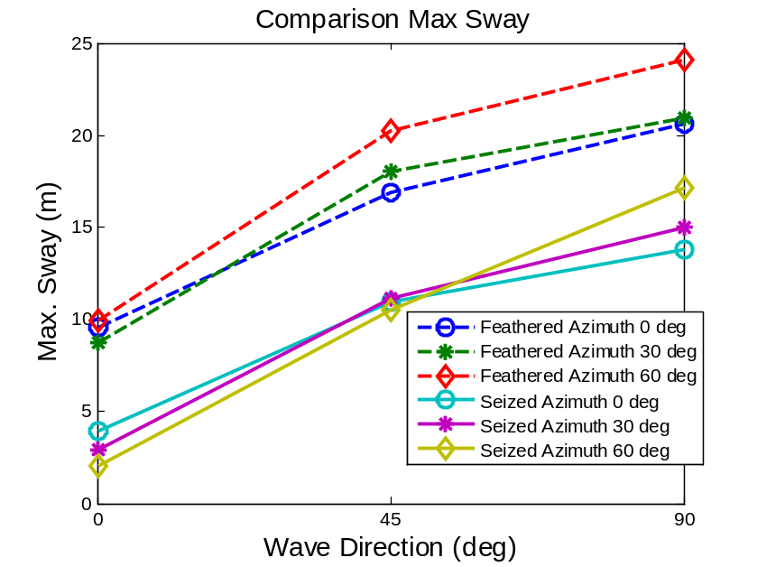
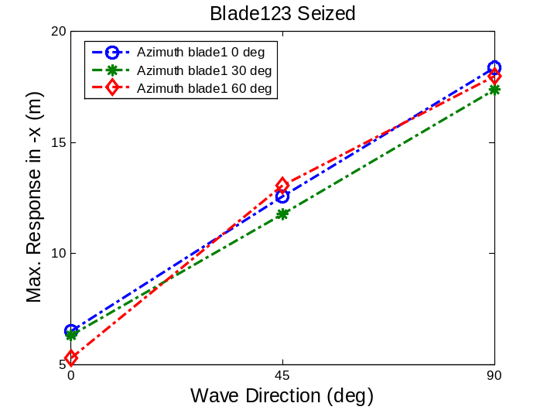

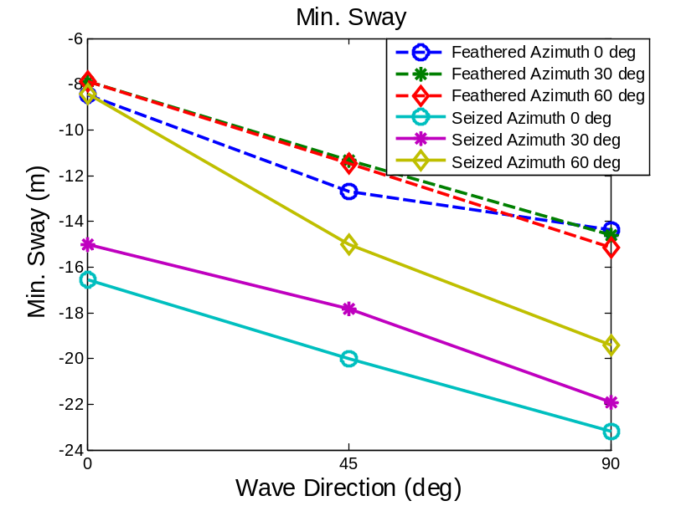
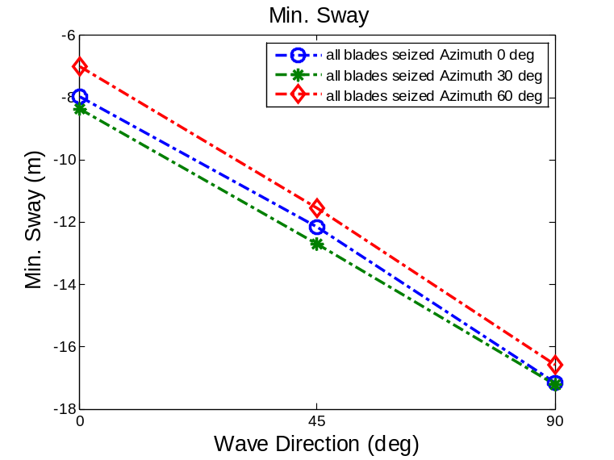
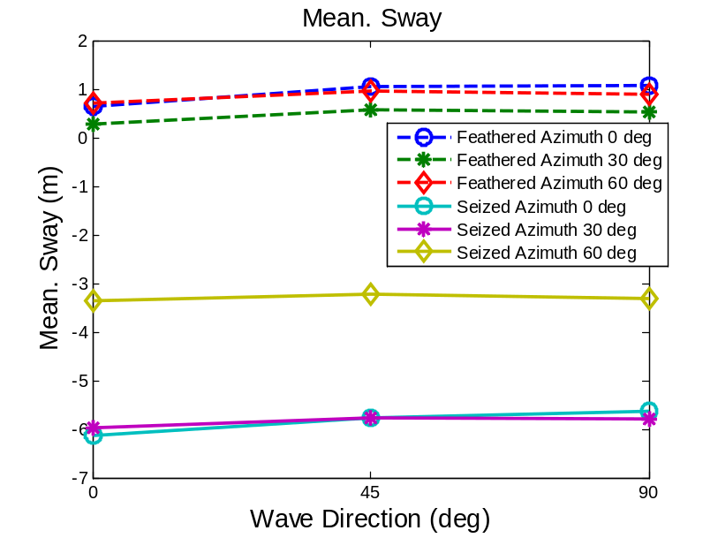
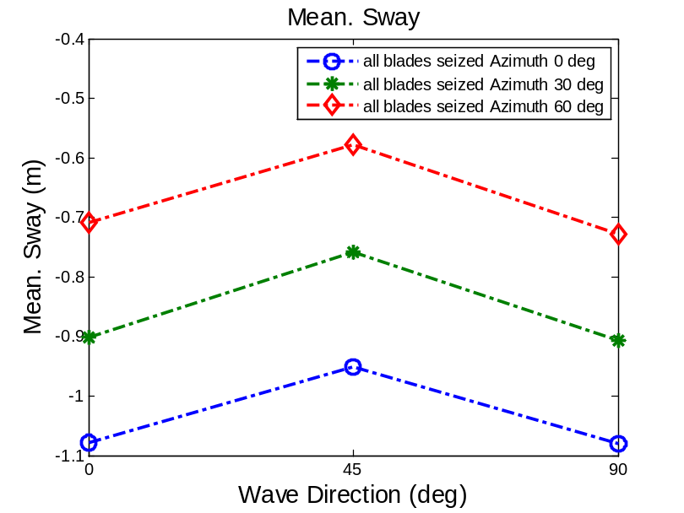
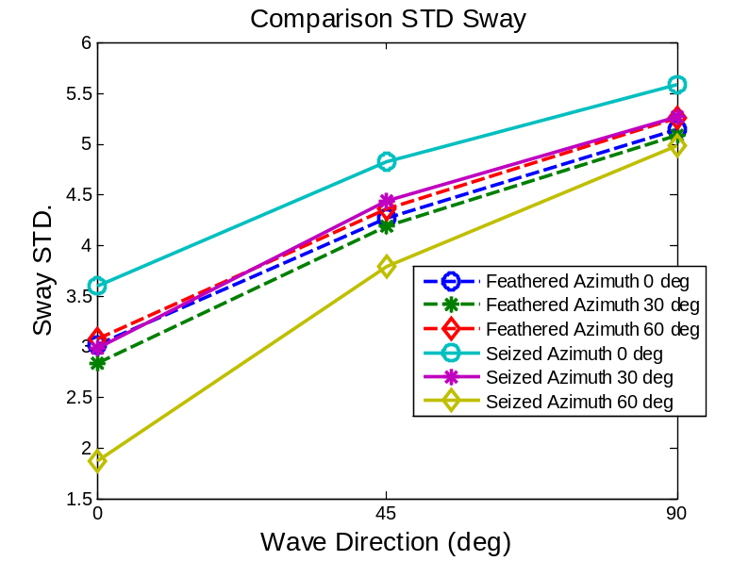
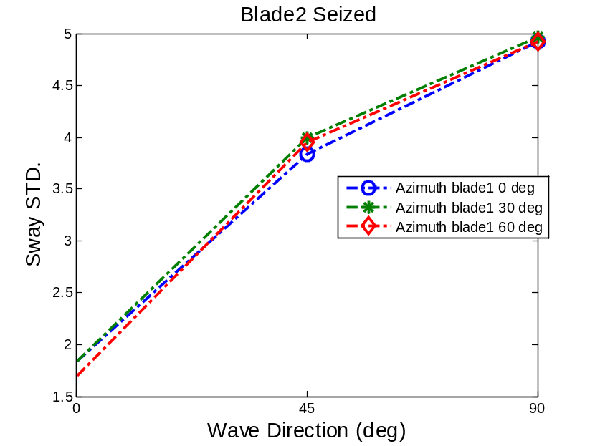
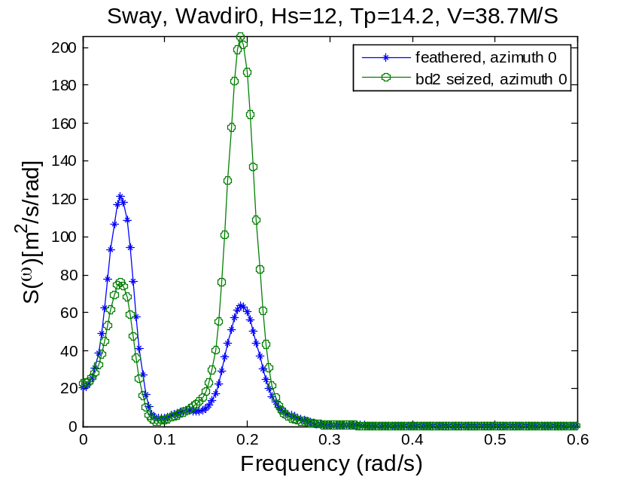
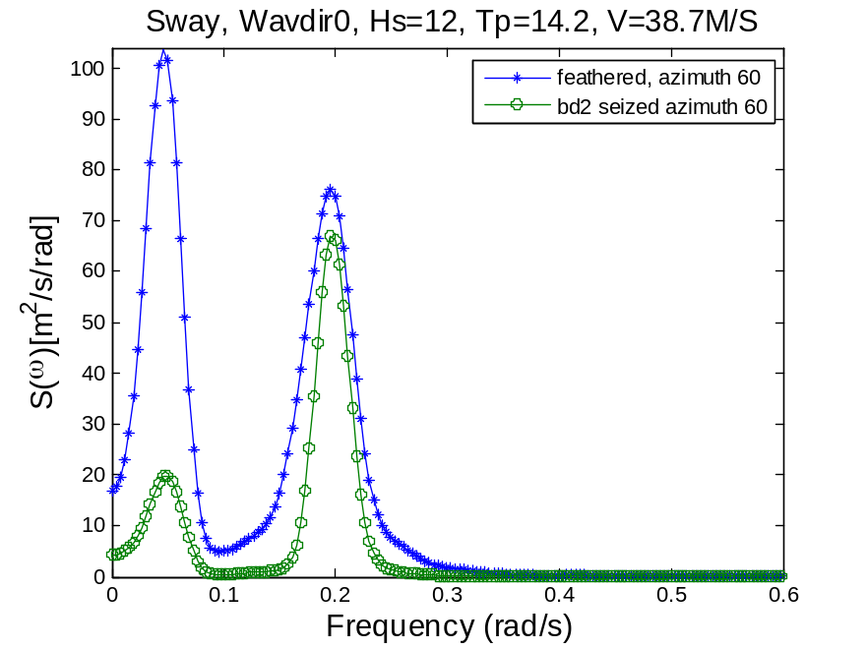
The feathered cases have larger maximum values and less minimum values compared with the fault cases because of large aerodynamic lift in the positive –x direction. The feathered cases have three blades providing lift while the fault cases only have two. The extremes are also more sensitive to the blade azimuth as the wave direction increases.
For the fault cases, the Nacelle STD in –x, i.e. sway is very sensitive to the azimuth angle of the blade. They may have worse dynamic response if azimuth is 0 deg. Since the blades are in an unsymmetrical position, there is stronger coupling of sway motion with roll motion, leading to unwanted large resonance at roll resonance. As wave direction increases, the sensitivity to blade azimuth decreases, indicating the significant of wave and wind interaction. Case seized_azimuth0 can be regarded as the most critical case concerning dynamic response.
The feathered cases are less sensitive to the blade azimuth.
The mean position is less sensitive to the wave direction, only dependent on the pitch and azimuth of the blades.
Surge
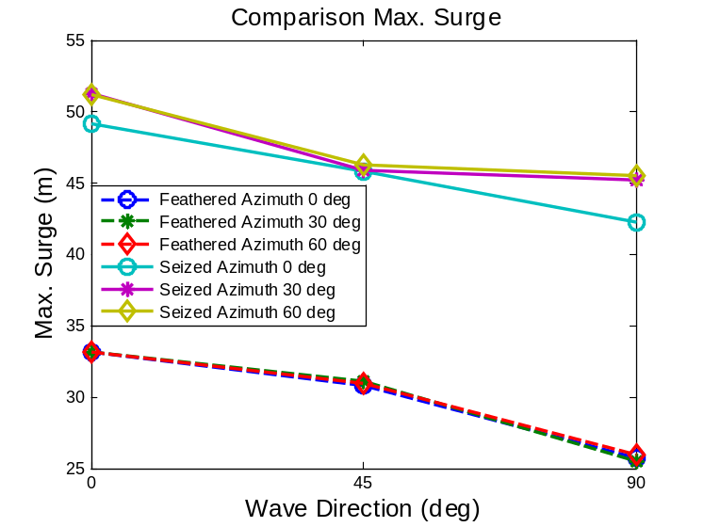
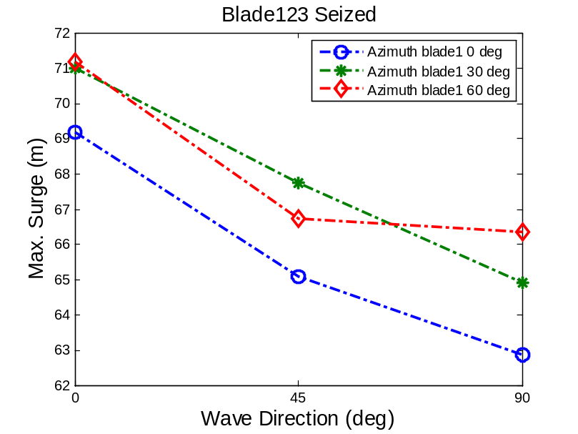
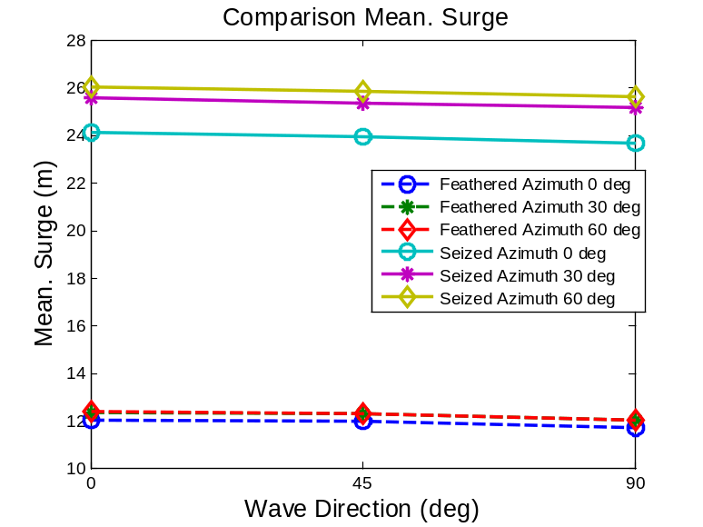
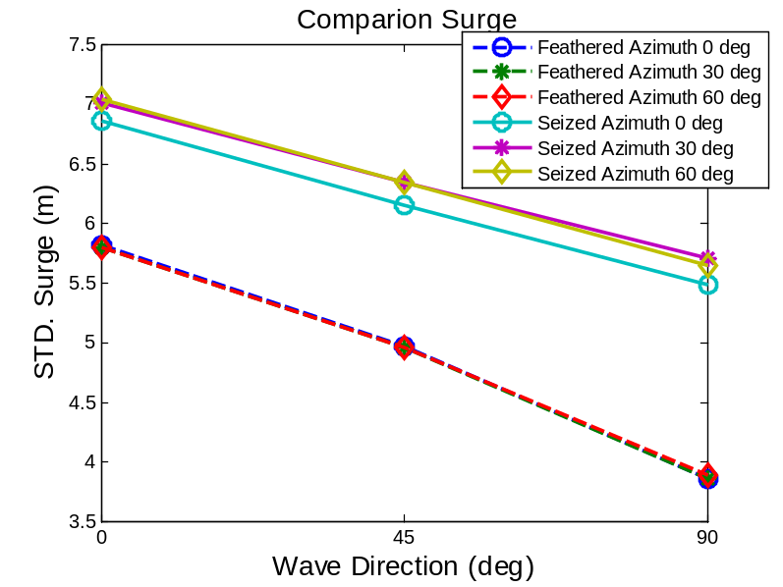
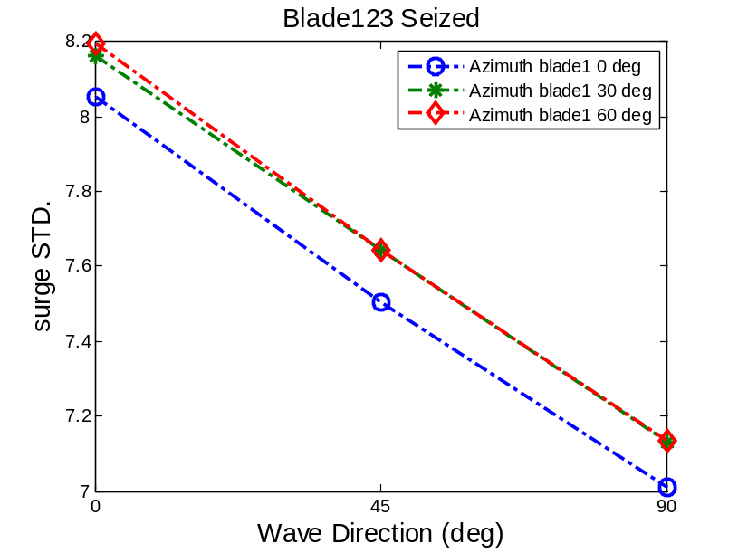
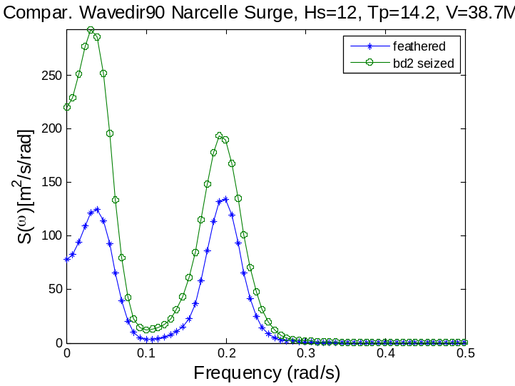
Fault cases will always have larger surge extremes and STD compared with the feathered cases. Due to the drag load on the seized blade2, more low frequency loads are created around the surge and pitch resonance frequency, leading to larger resonance peaks. These values are more sensitive to the wave direction than to the azimuth. The largest surge value is observed as 51.2m for the seized case for azimuth 30 and 60 deg, exceeding that of the feathered case, 33.15m, by 54.12%.
The fault cases always lead to larger responses compared with the feathered cases due to the increased drag force in –y direction. The difference is largest when wave direction is 90 deg and azimuth is 30 or 60 deg.
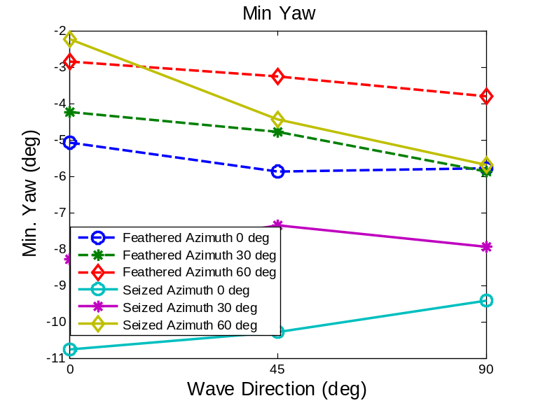
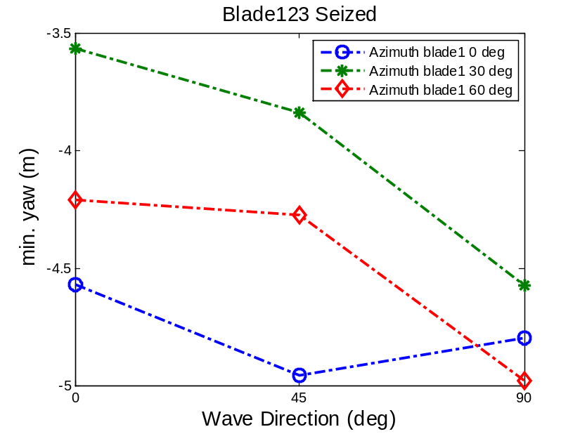
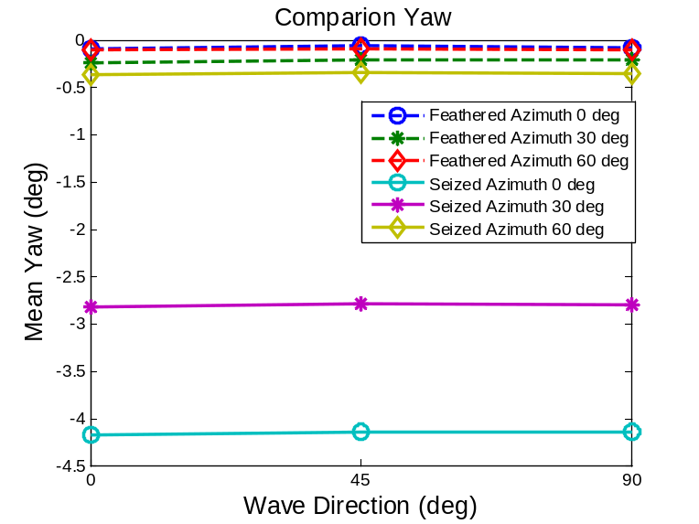
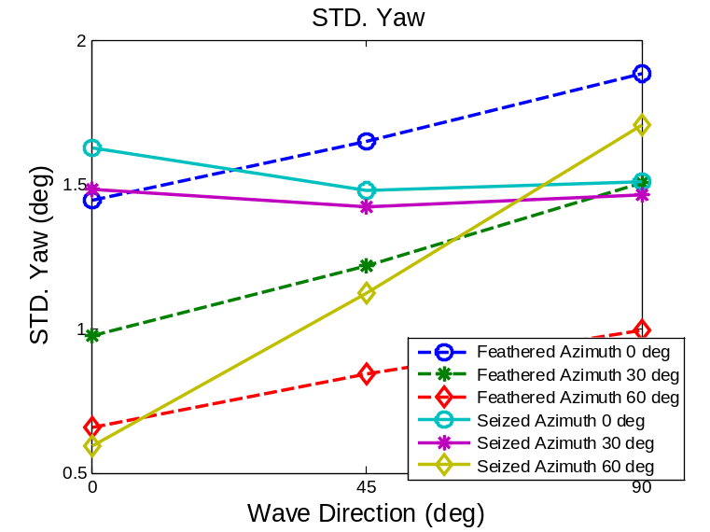
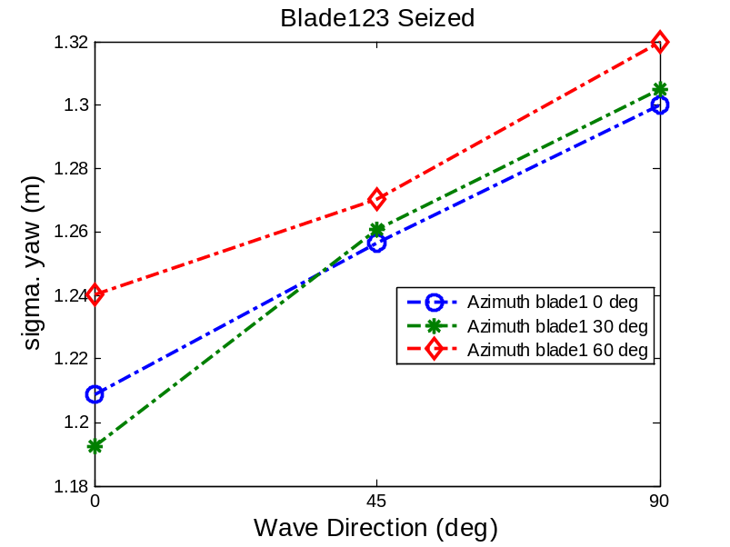
Wave direction 0 deg, azimuth 0 deg:
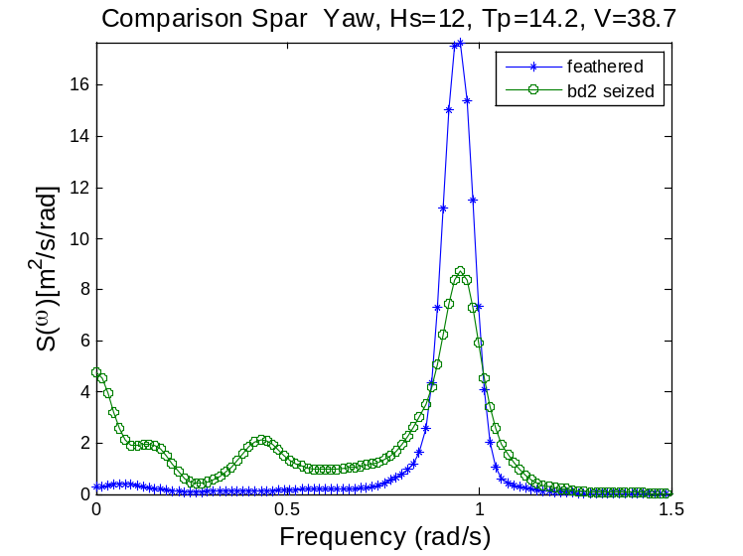
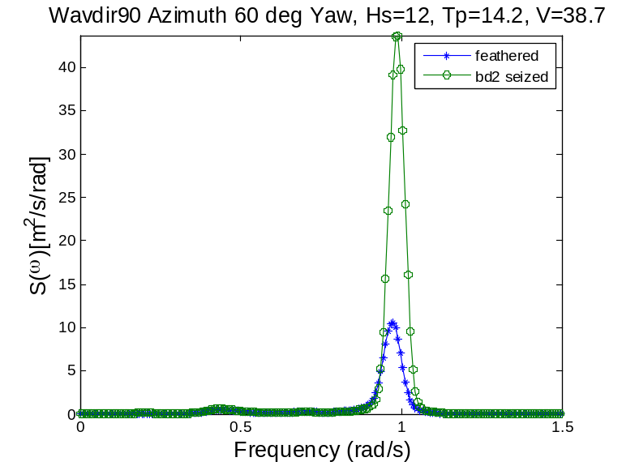
Yaw angle is very susceptible to the blade azimuth position. No wave-induced peak is present in the yaw response when the direction is 0 but slight wave resonance is observed the direction is 90 deg. For a fully feathered parked turbine, the largest yaw angle is around -5.8 deg for azimuth 0 deg and azimuth 30 deg at wave direction 90 deg. The difference between two parked azimuth positions could be 54.5%. For a fault turbine with one blade seized, the worst case is the azimuth 0 deg case, which leads to an overly large yaw response of 10.8 deg when wave direction is 0 deg. The symmetrical position azimuth 60 leads to the lowest yaw response at all the wave directions considered.
It is found that the mean position of yaw is insensitive to the wave direction and dictated by the wind only. For the fault cases, the mean position is negative (anticlockwise to the –z axis) when azimuth is 0 or 30 deg. The STD values are sensitive to the azimuth position. The frequency domain response spectrum of the yaw motion for the fault cases are less peaked, however, compared with the normal parked cases. Due to the increased aerodynamic damping provided by the sized blade2, the yaw resonant peak is much lower. The wave frequency response pops up however.
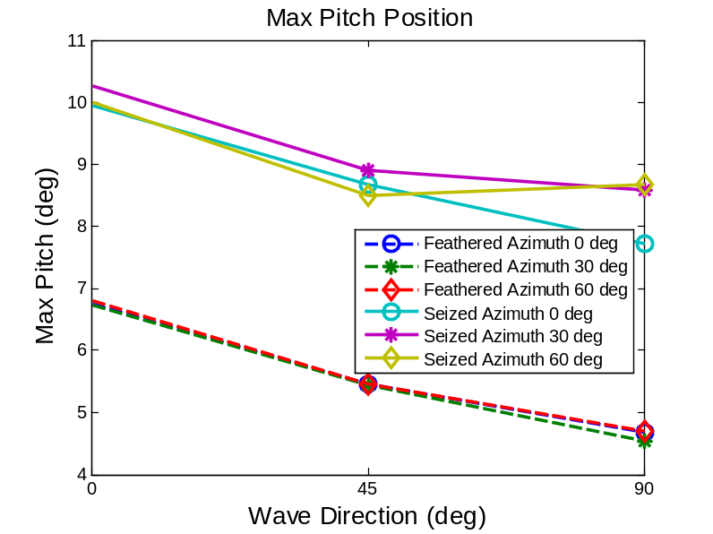
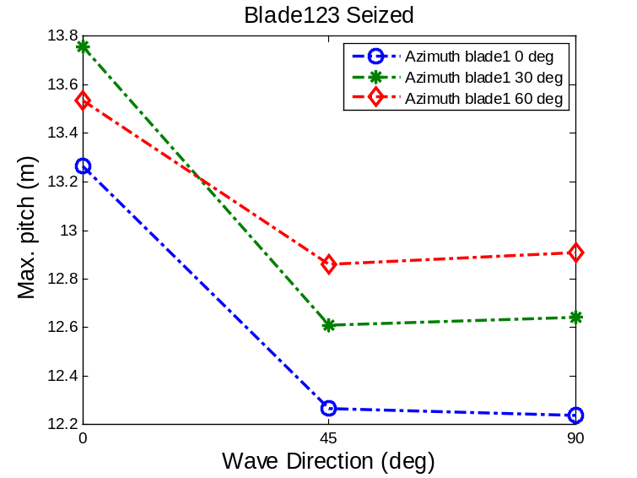
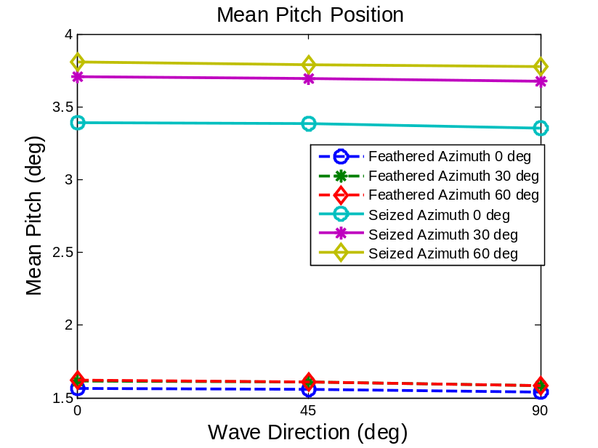
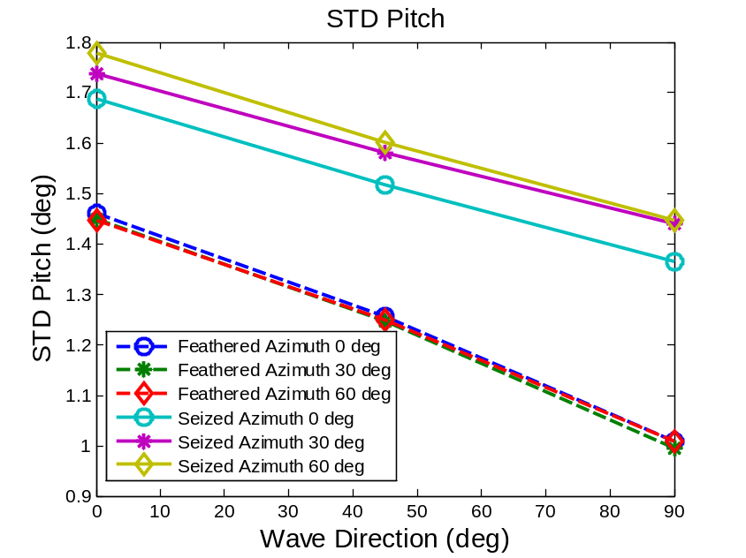
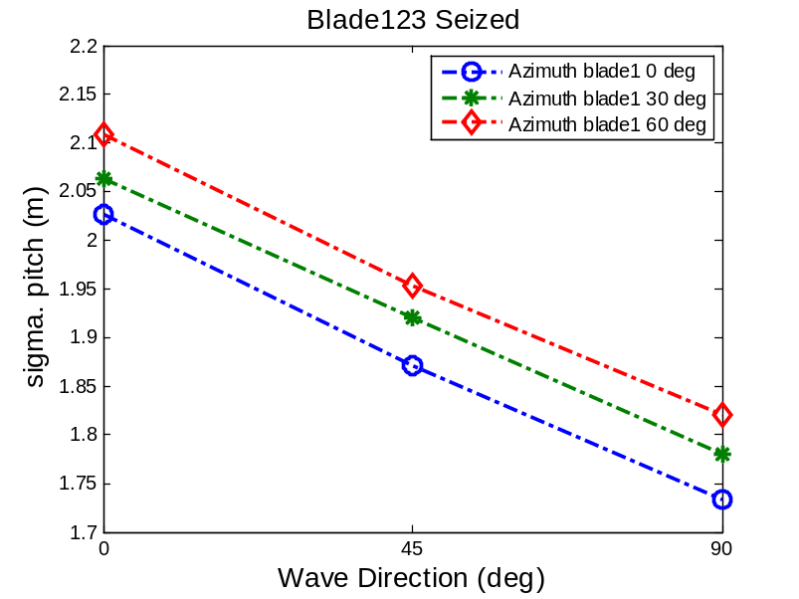
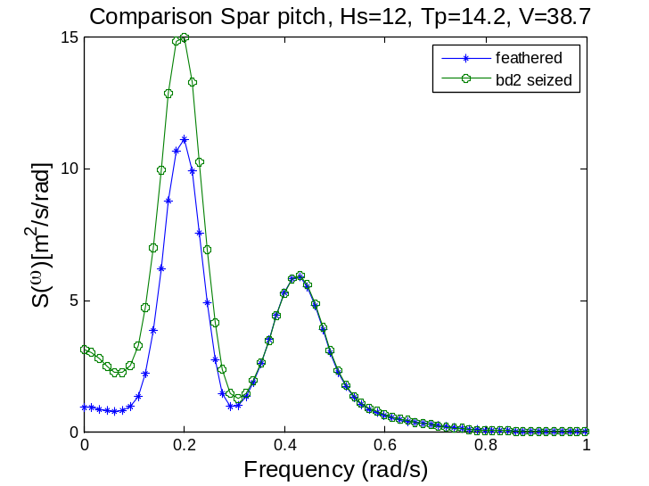
Pitch: The feathered cases have close response regarding maximum, mean and std. They are sensitive to the wave direction. Fault cases usually lead to a tilted mean position and comparatively larger extreme values. At wave direction 90 deg, the difference for maximum can be large as 12.3%. Both of the azimuth 30 and 60 cases can be deemed as critical at wave 0 deg. The max pitch angle for seized case is 10.3 deg, exceeding that of the feathered case, 6.8 deg by 51.5%. The mean position of pitch, like that of the yaw motion, is insensitive to the wave direction.
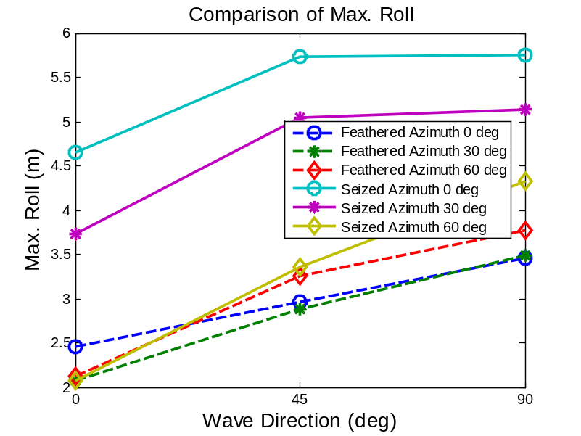
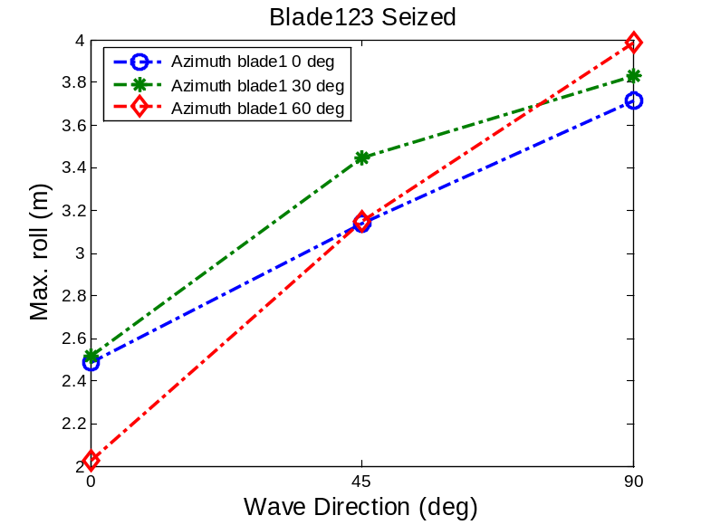
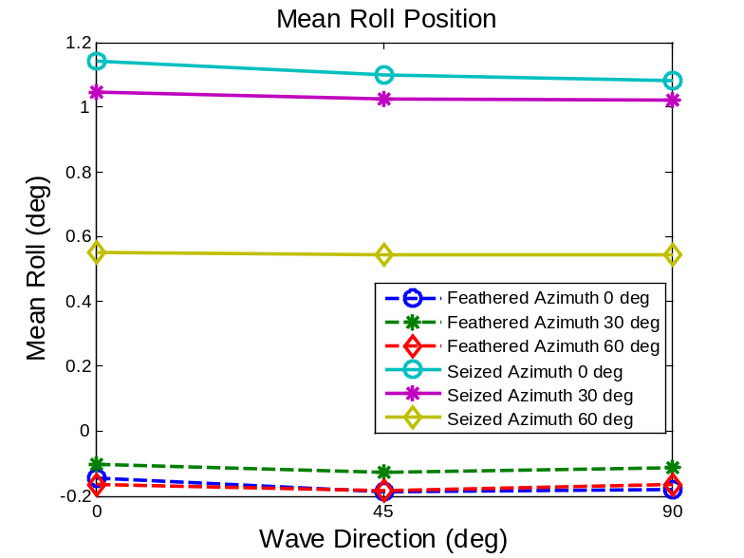
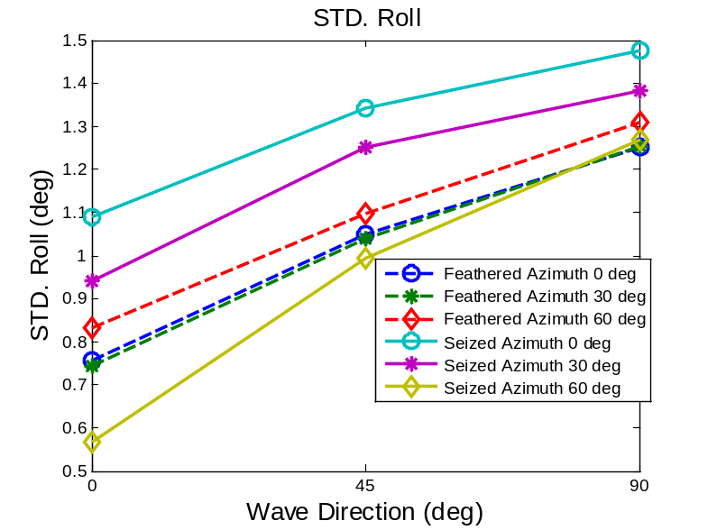
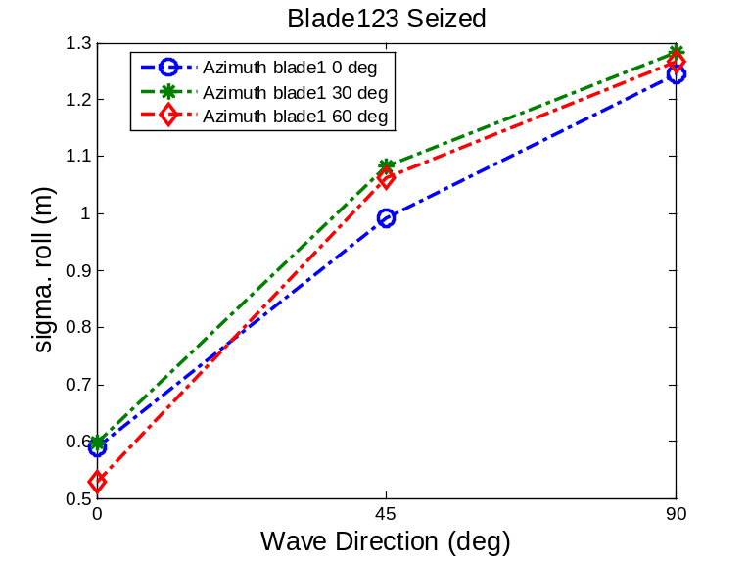
Wave direction=0
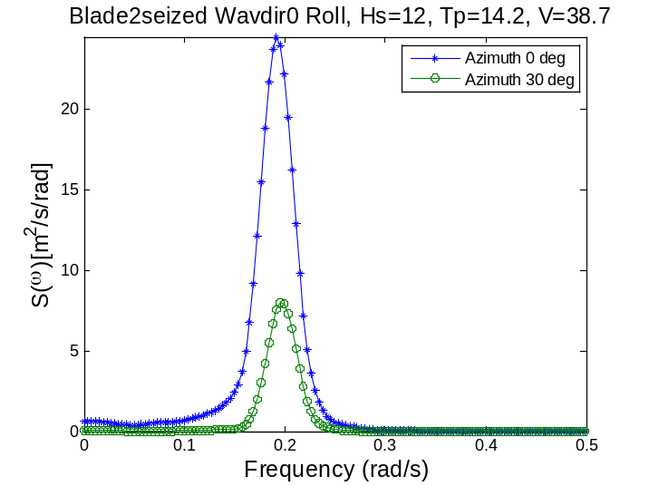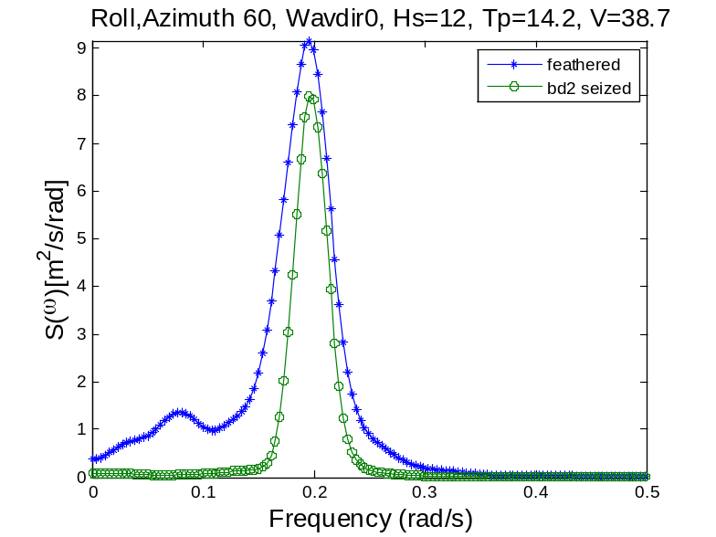

The maximum and STD are highly sensitive to the azimuth angle. For the roll motion concerned, the mean value is insensitive to the wave direction. Seized cases, azimuth 0 and 30, always lead to larger roll resonance in the responses. The wave resonant peak in the roll response is sensitive to the wave direction. When wave direction is 0, there is no wave-frequency peak. When direction is 90 deg, due to the alignment of wave and roll motion, wave frequency resonance is excited. The maximum roll reaches 5.75 deg for the fault case at azimuth 0 deg and wave direction 90 deg. The most critical azimuth is 0 deg. The maximum STD is this case exceeds the maximum feathered response by 12.2%.
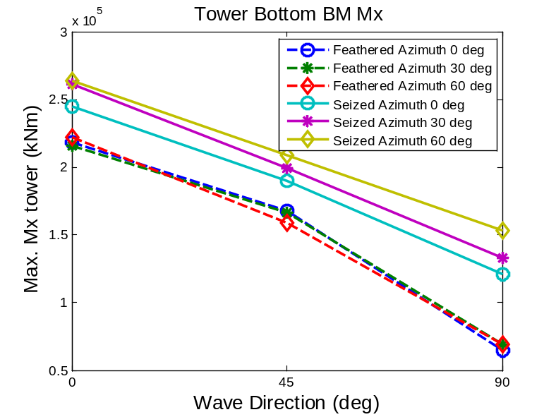
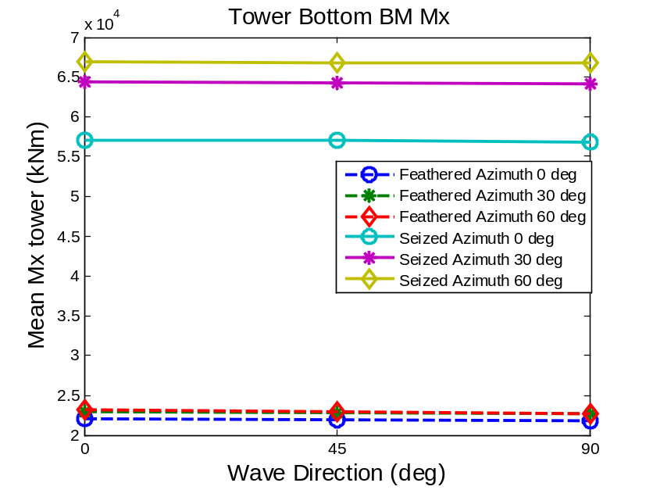
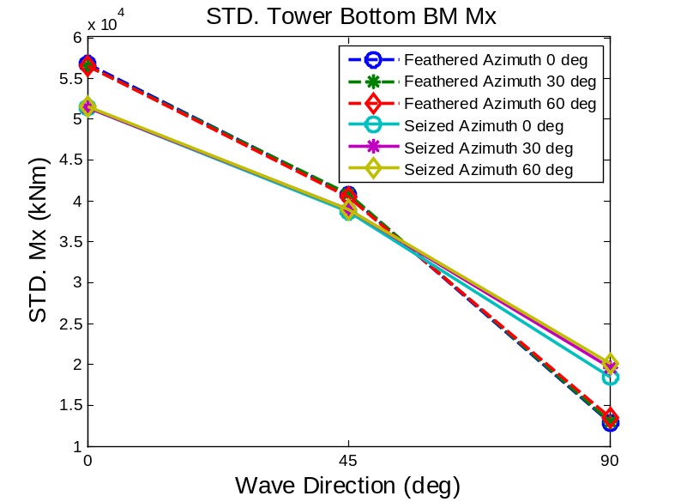
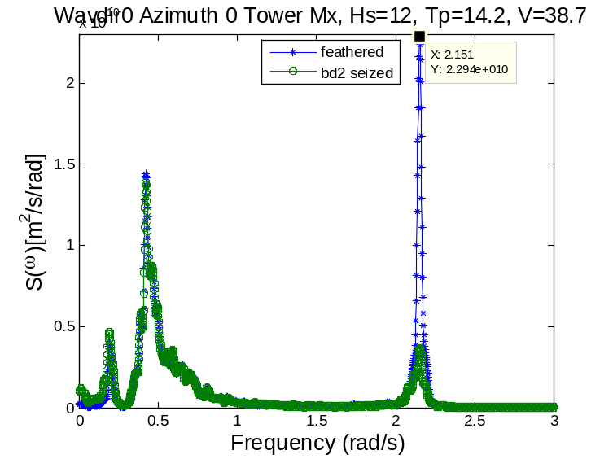

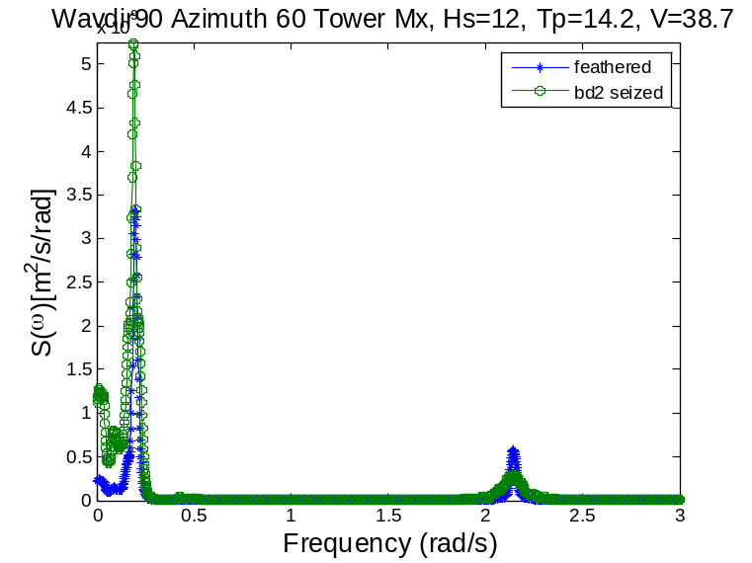
The max and STD of the responses are sensitive to the wave direction. The mean value is not. The feathered cases are less sensitive to the azimuth angle compared with the seized cases. The maximum and mean values of the fault cases are also sensitive to the blade azimuth. The standard deviations are not. It is observed that the fault cases are linked with larger extreme values and mean values. The seized azimuth 60 deg can be regarded as the most critical one concerning the extreme response. The maximum Mx of the fault case occurs at wave direction 0 deg, exceeding that of the feathered case by 18.7%. Regarding the STD, the fault cases are not necessarily critical. The first mode fore-aft natural frequency is seen in the response of Mx when wave direction is 0 deg. For the seized cases, the aerodynamic drag in –y direction is larger, creating a damped peak in around 2.2 rad/s.
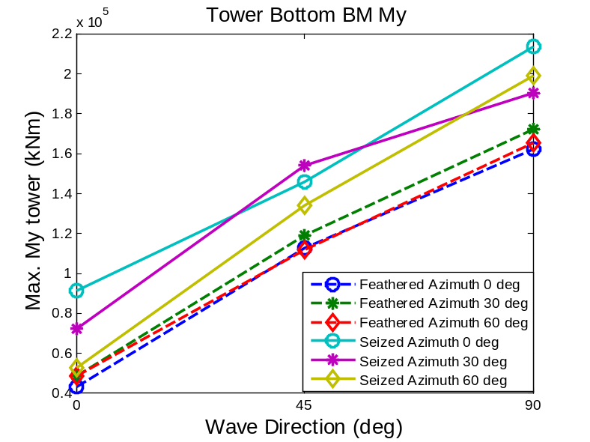
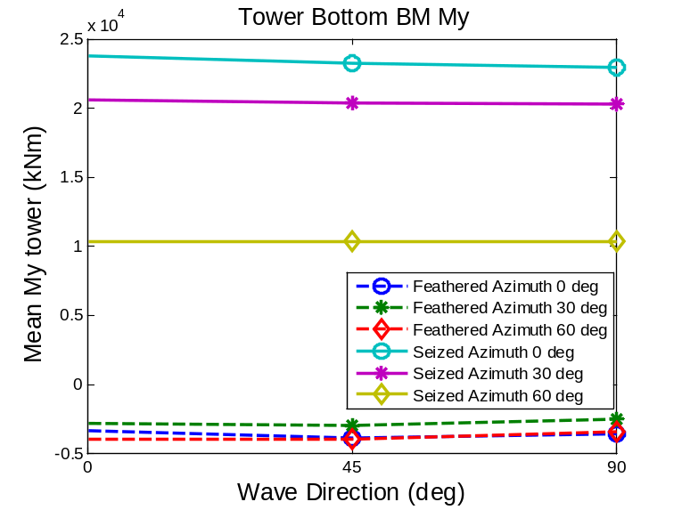
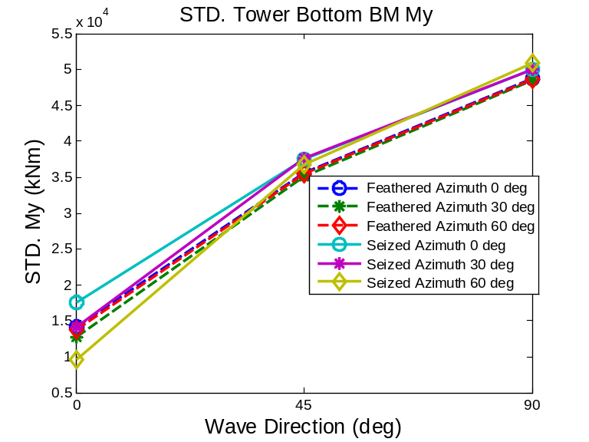
The maximum values of the My are slightly sensitive to the azimuth angle and wave direction. The mean values of the seized cases are only sensitive to the azimuth angle. The STD of My is less sensitive to the azimuth position regardless of the blade pitch, i.e. blade2 is seized or not. It is very sensitive to the wave direction still. Seized azimuth 0 deg could be the most critical case. The maximum My of the fault case is 198997 kNm, which occurs at wave direction 90 deg and blade azimuth 0 deg. This value exceeds the maximum of the feathered case by 15.6%.
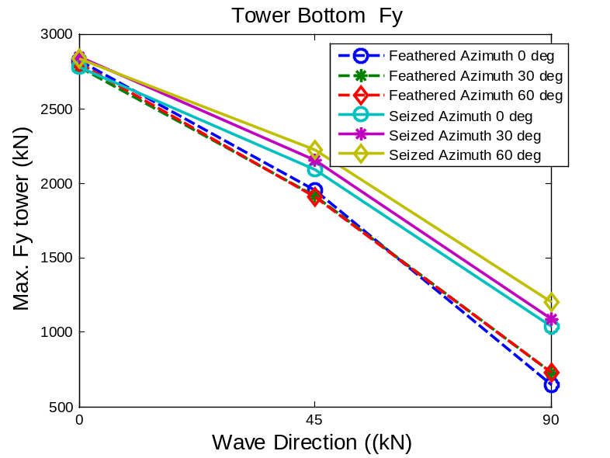
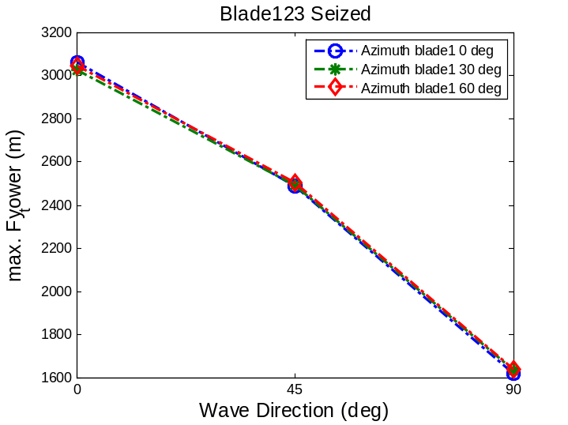
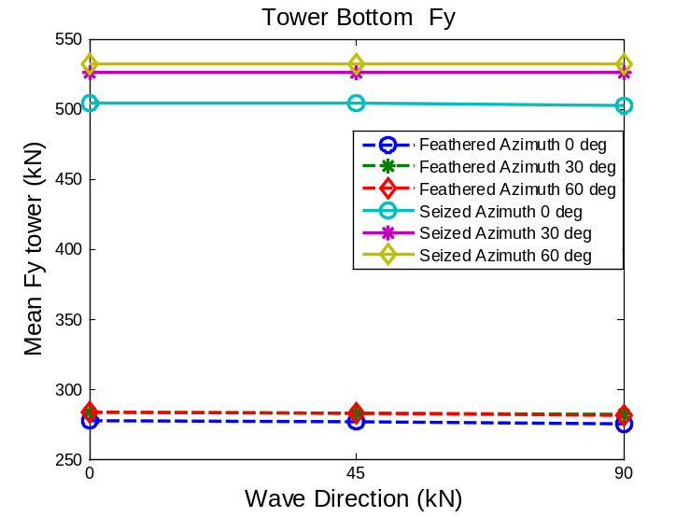
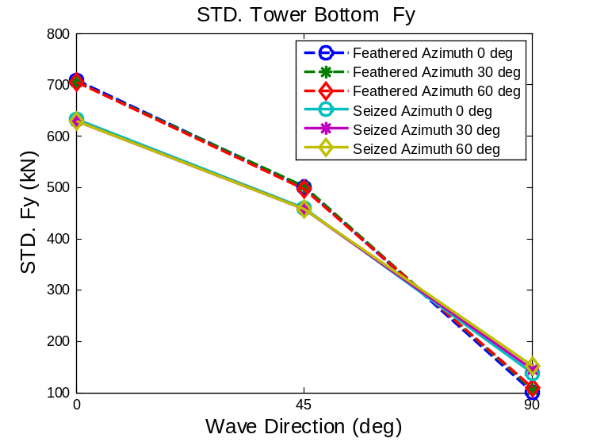
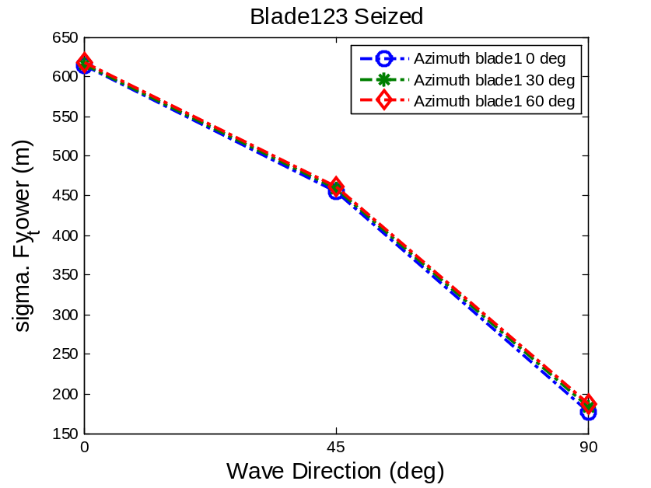
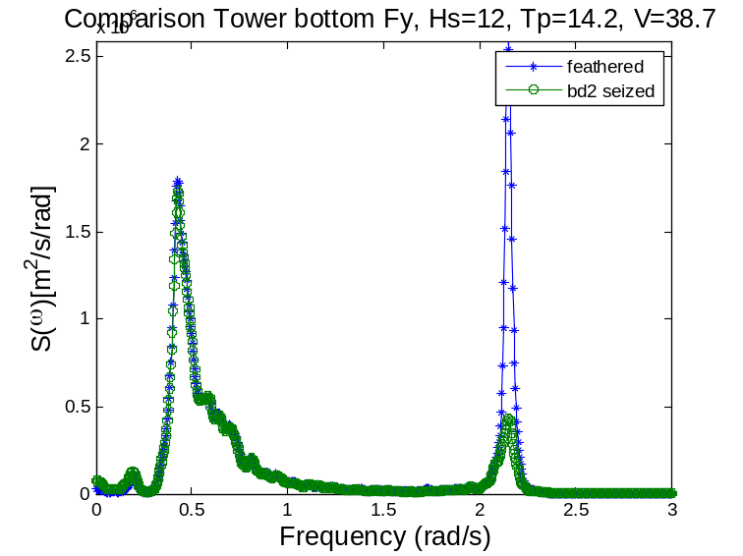
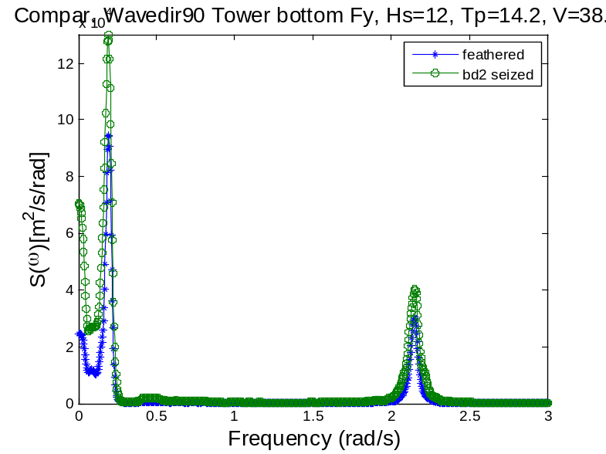
The maximum of the tower bottom shear force Fy is not very sensitive to the blade azimuth but sensitive to the wave direction. All of the cases studied have similar extremes at wave direction 0 deg, but quite different extremes at wave direction 90 deg. The fault cases produce larger maximum compared with the feathered cases, leading to a 63.76% increase of shear force at wave direction 90 deg. This value may not be critical to the safety of the turbine, however, since the maximum occurs at wave direction 0 deg.
The STDs are not sensitive to the blade azimuth, but highly sensitive to the wave direction.
The mean values are not sensitive to the wave direction.
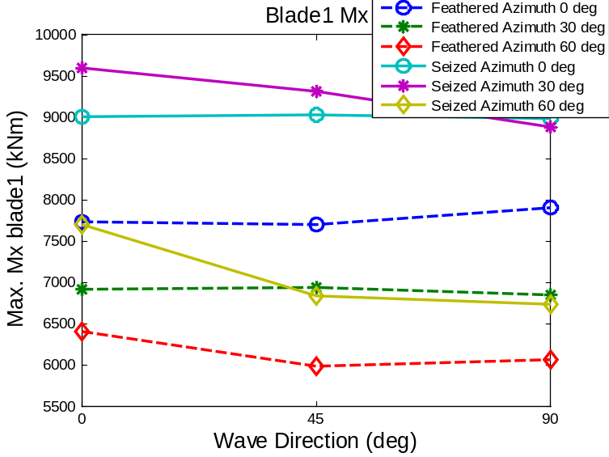
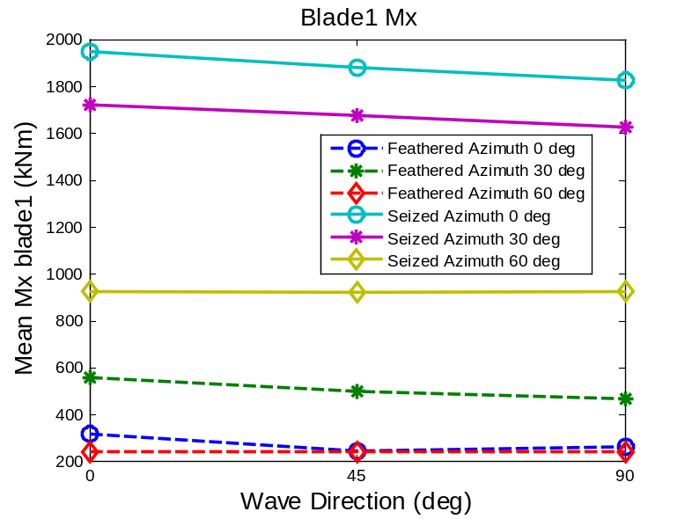
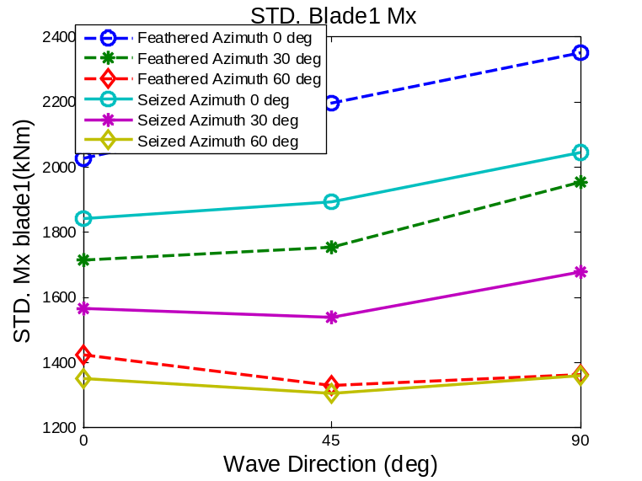
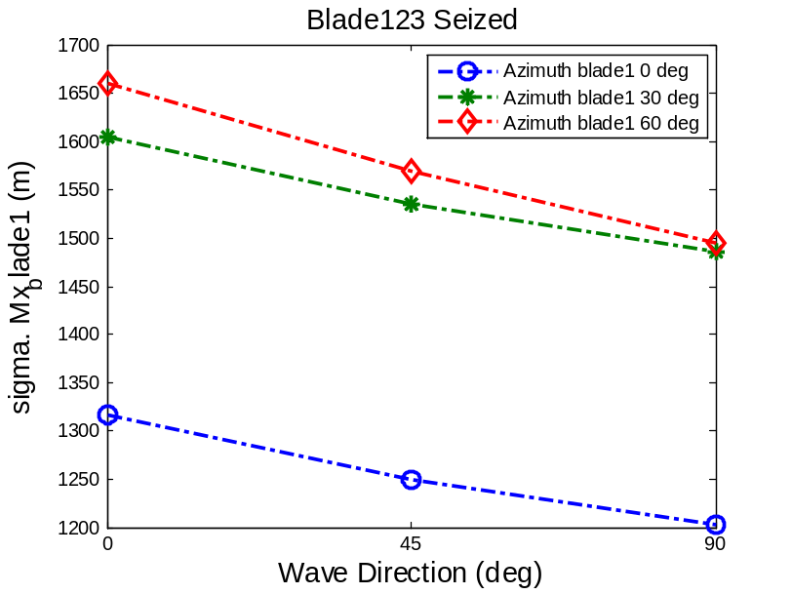
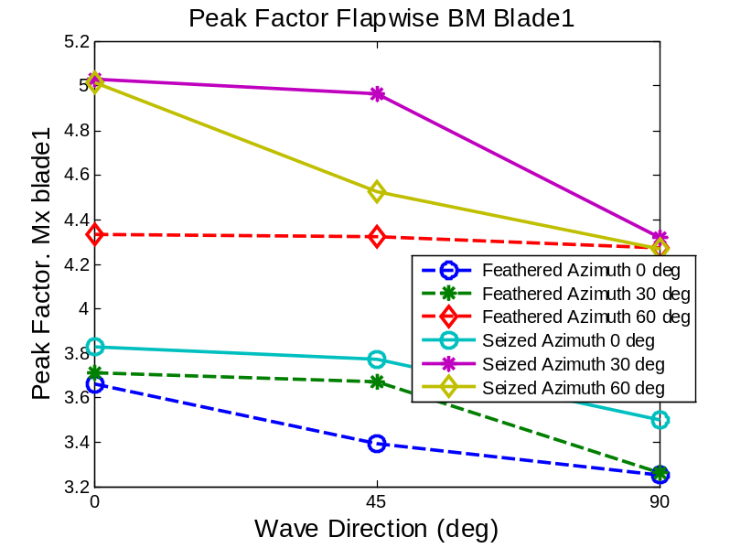
It is shown that the flapwise bending moment Mx of blade1 is generally less sensitive to the change of wave direction. It is more sensitive to the blade azimuth and hence wind load. The unsymmetrical seized cases, azimuth 0 deg and azimuth 60 deg have larger extreme and mean values. Similar trend can be observed for Roll and tower bottom bending moment My responses.

Tip speed of blade1:
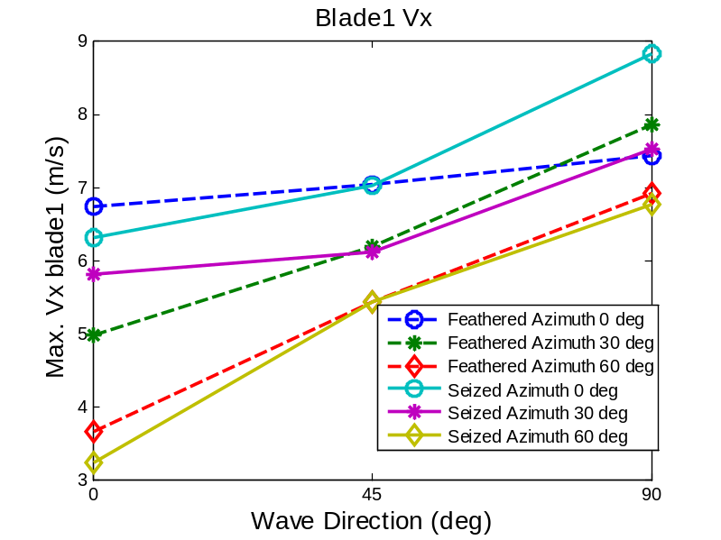

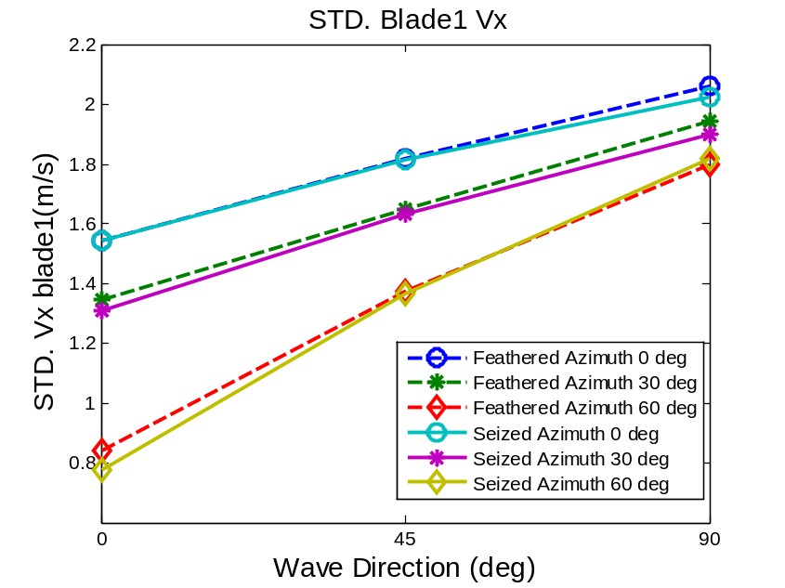
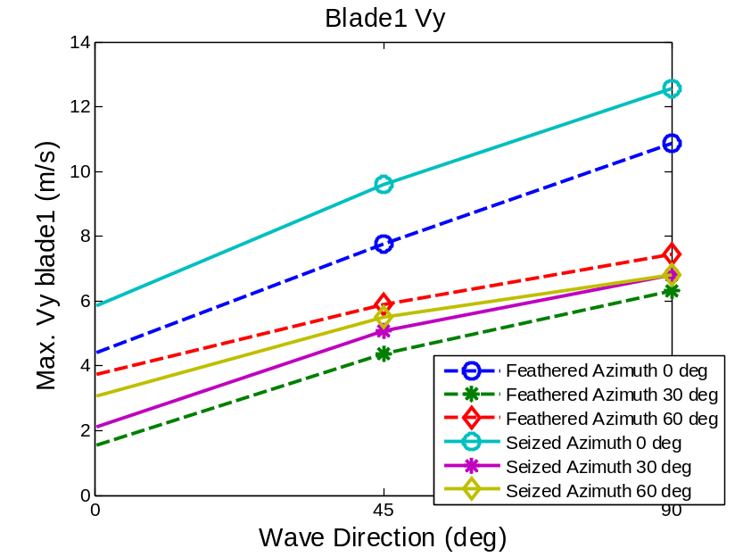
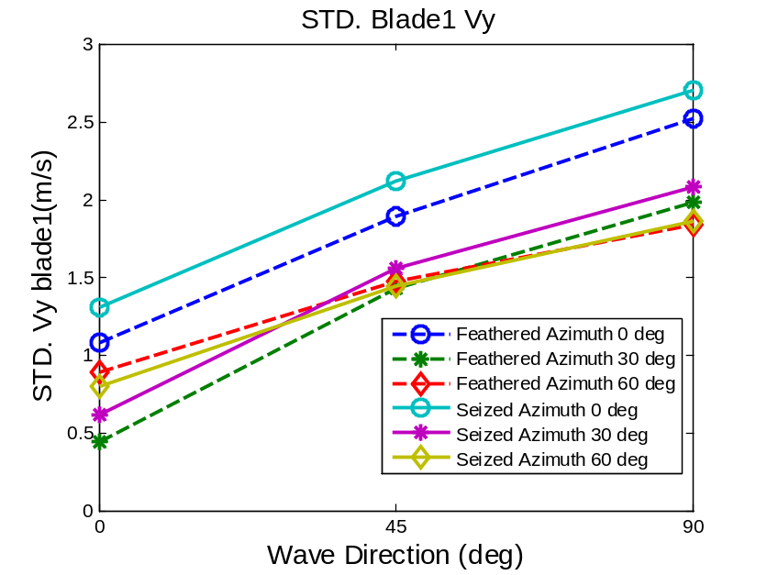
The tip velocity of the blade1 is mainly due to the rigid body motion of the platform. They are sensitive to the blade azimuth and wave direction. The fault cases do not necessarily lead to large ones.

Sea state4, all blades feathered, Uw=49.4, Hs=15.6, Tp=15.4
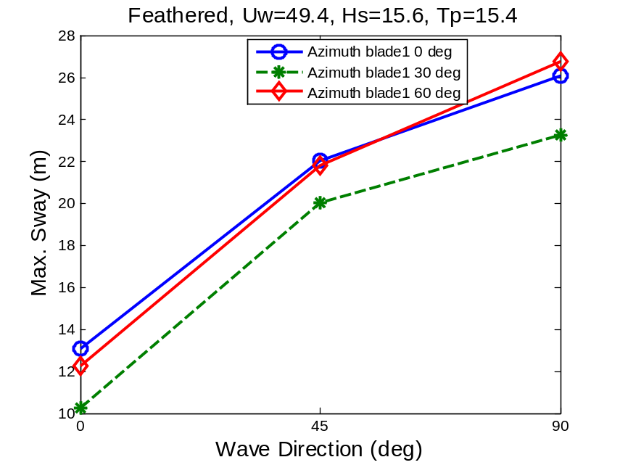
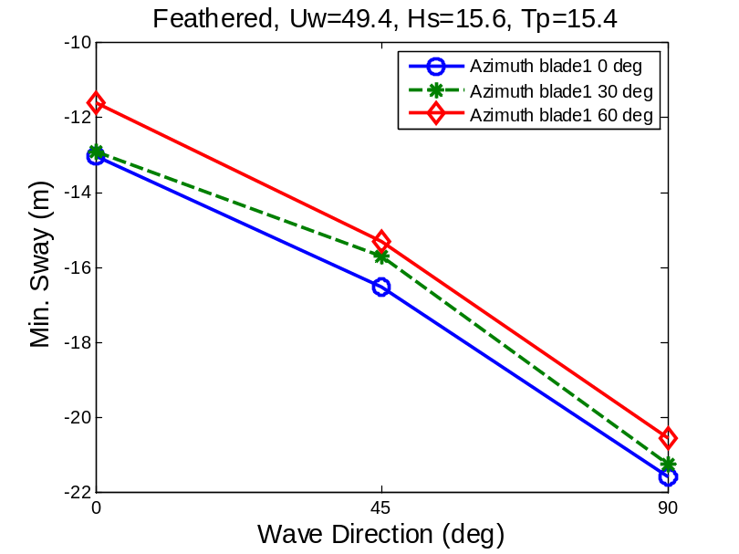
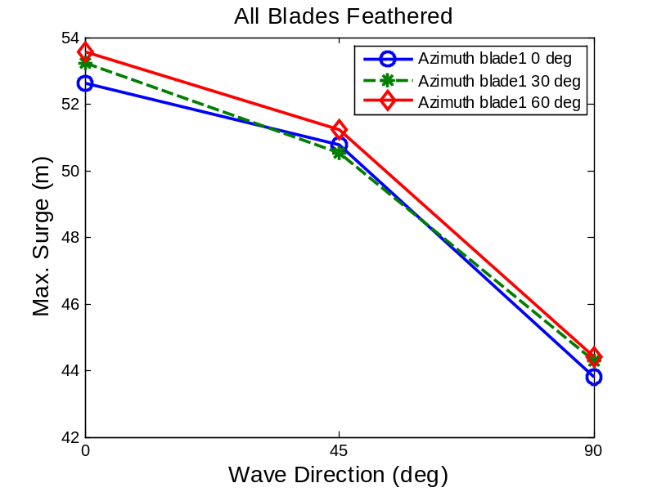
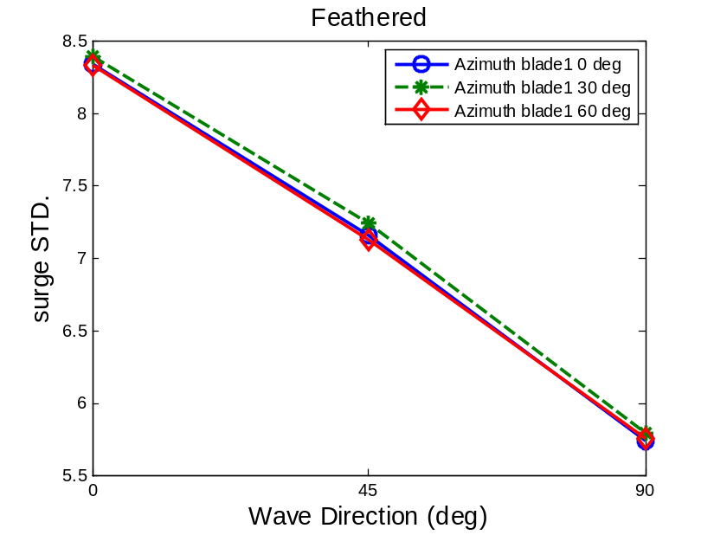
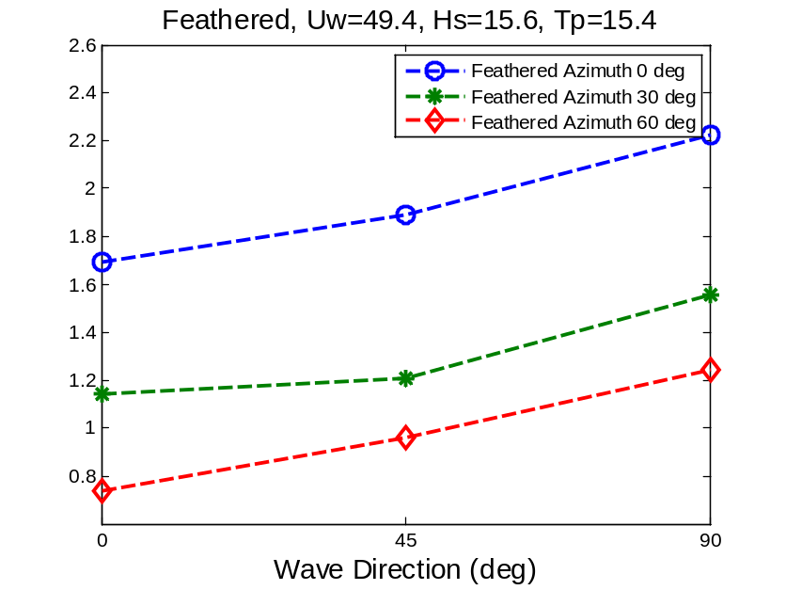
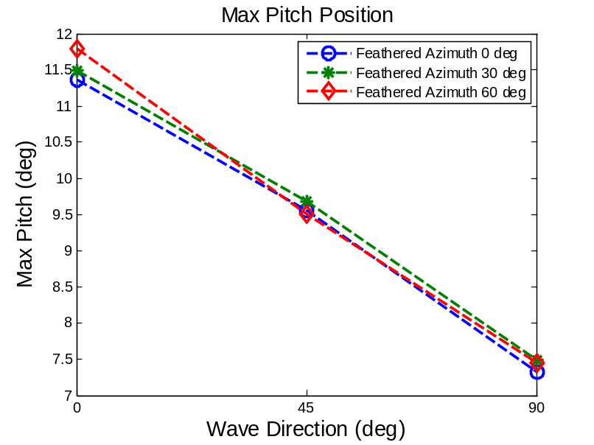
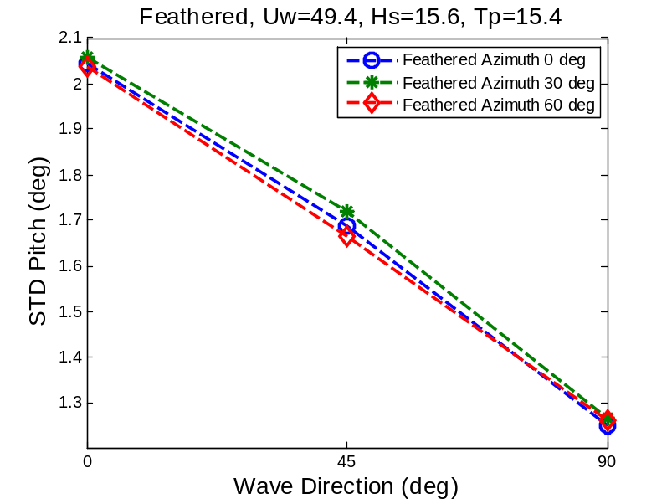

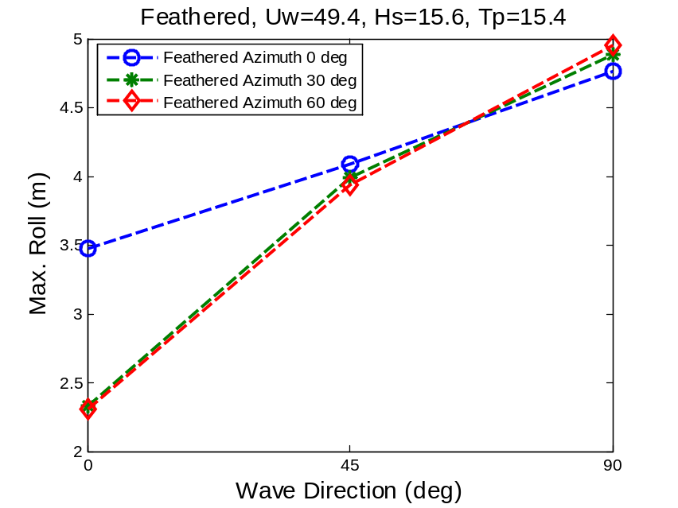

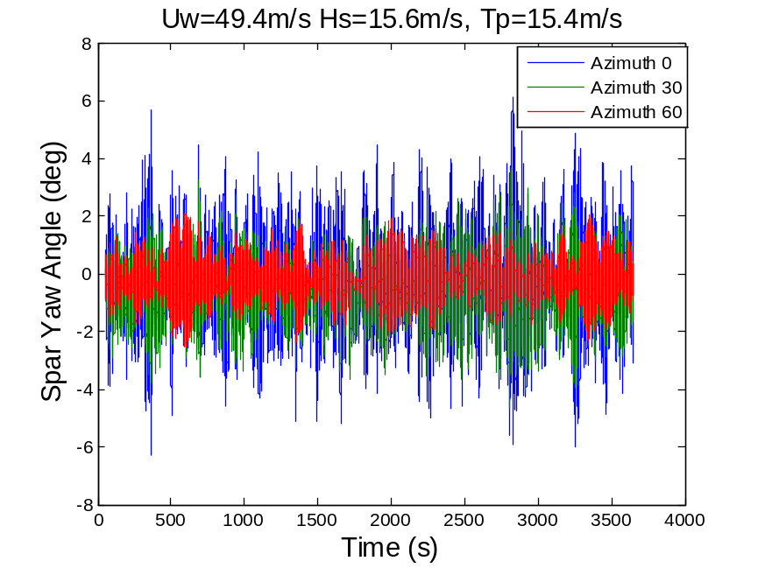
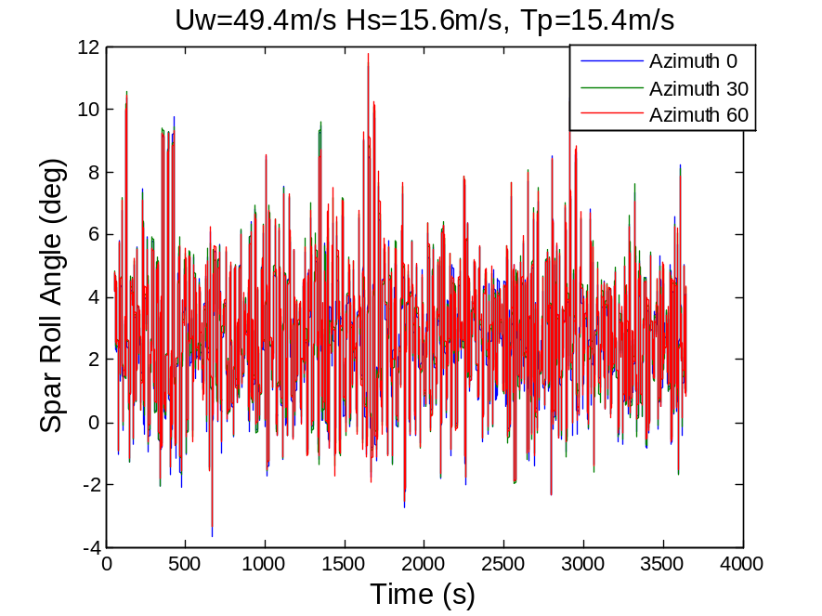
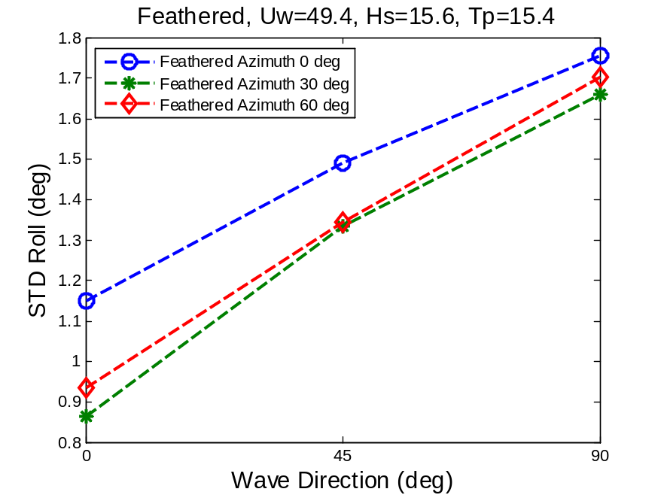
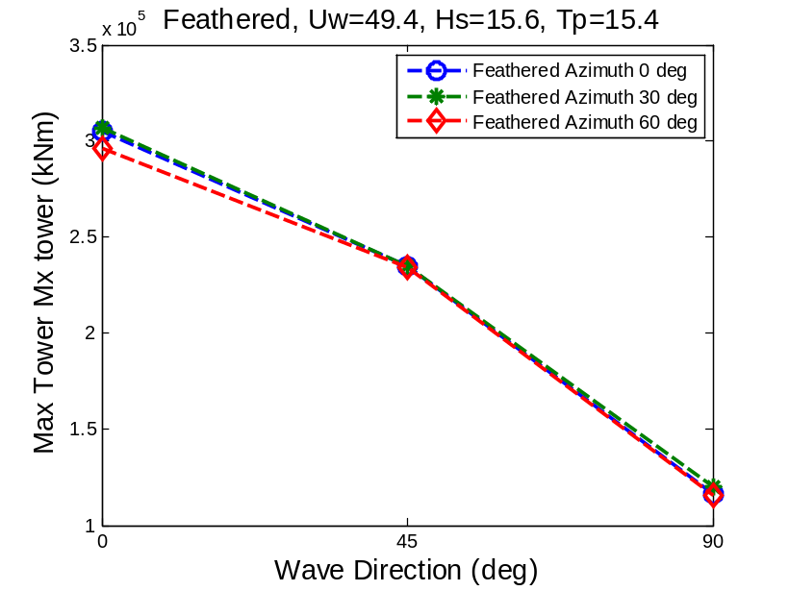
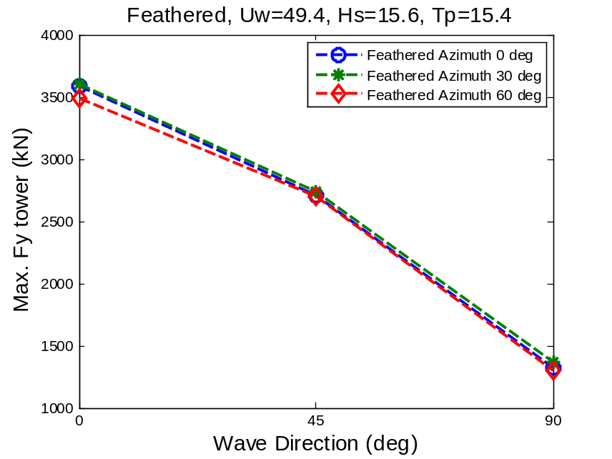
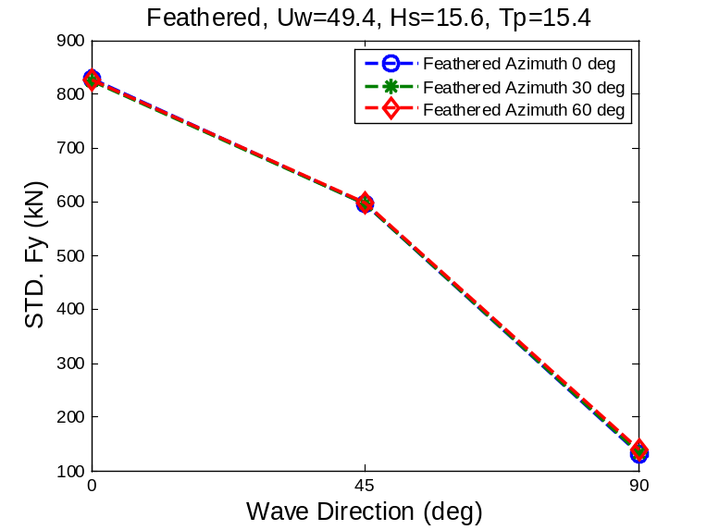
Comparison with 50-yr normal case
Normalized extremes
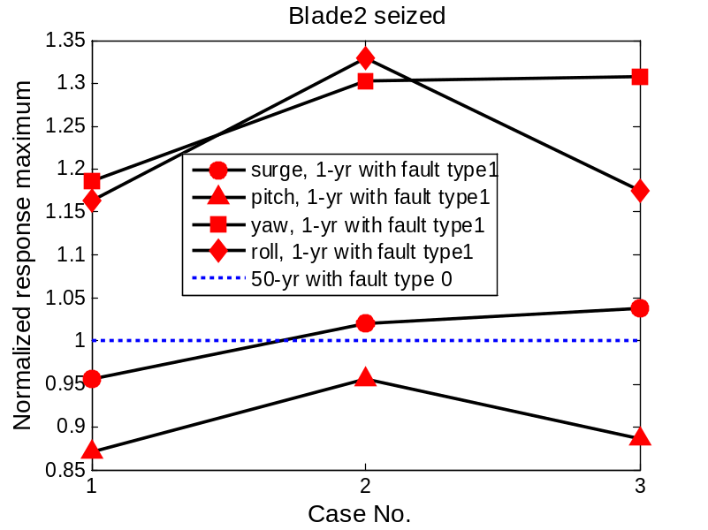

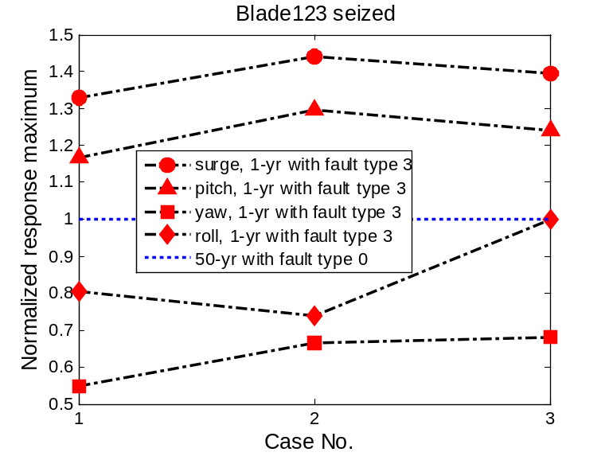
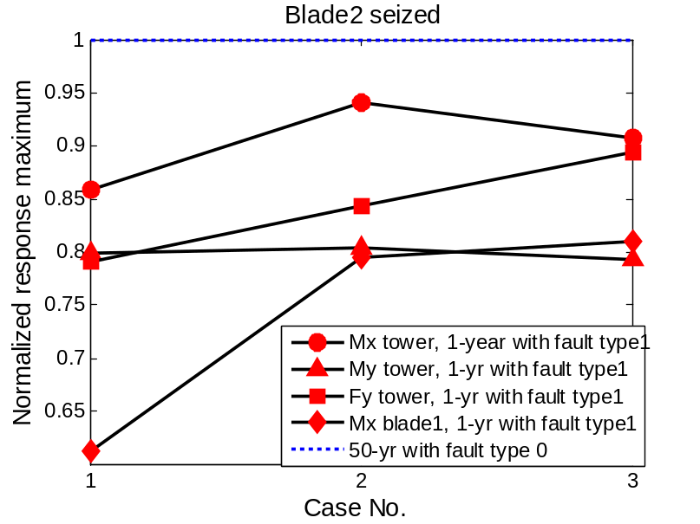
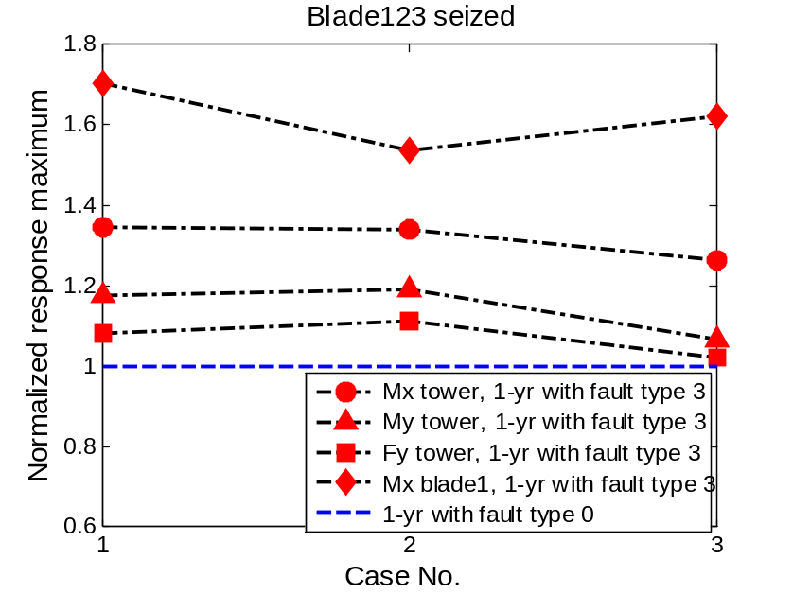
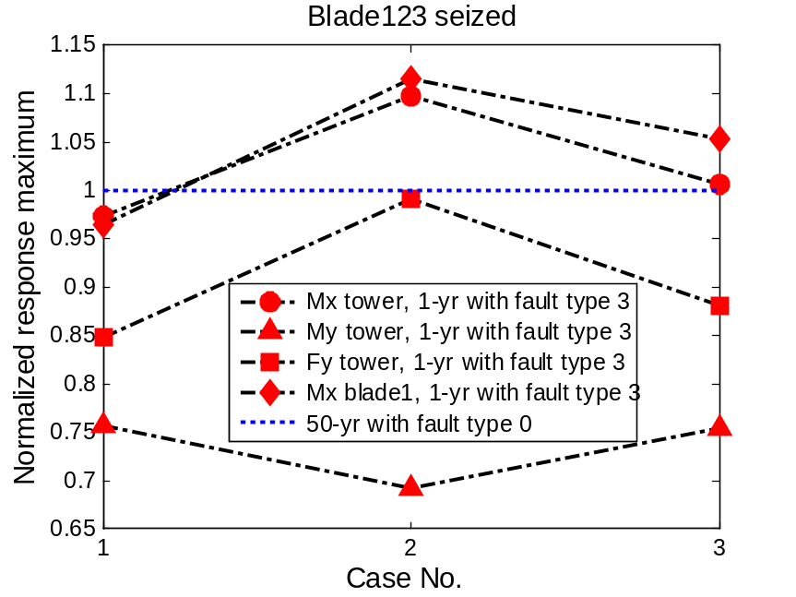
Normalized std.
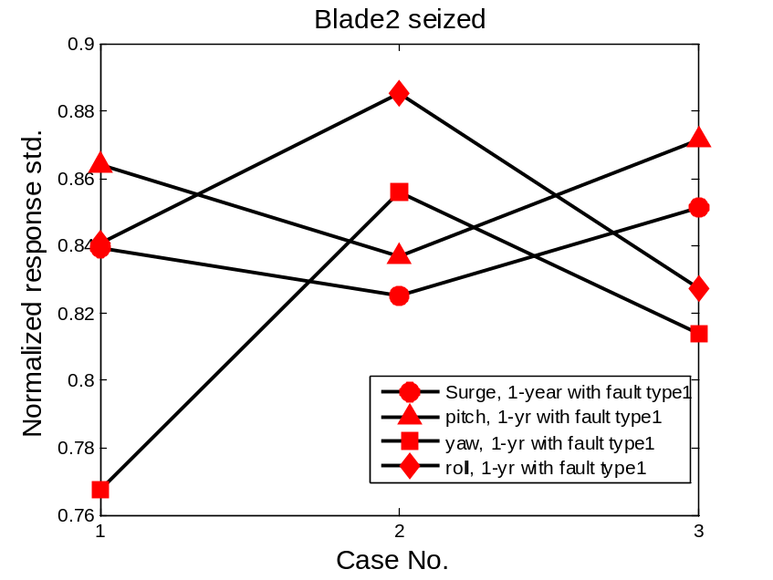
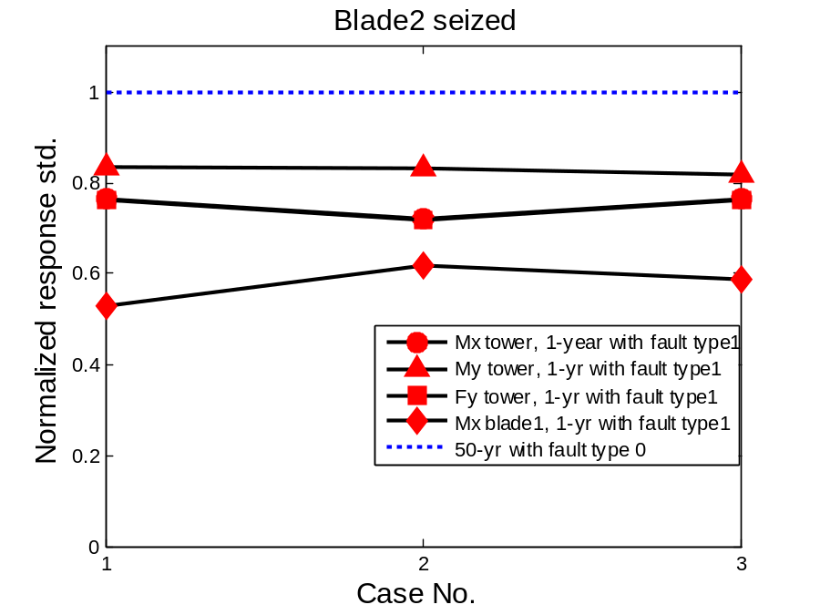

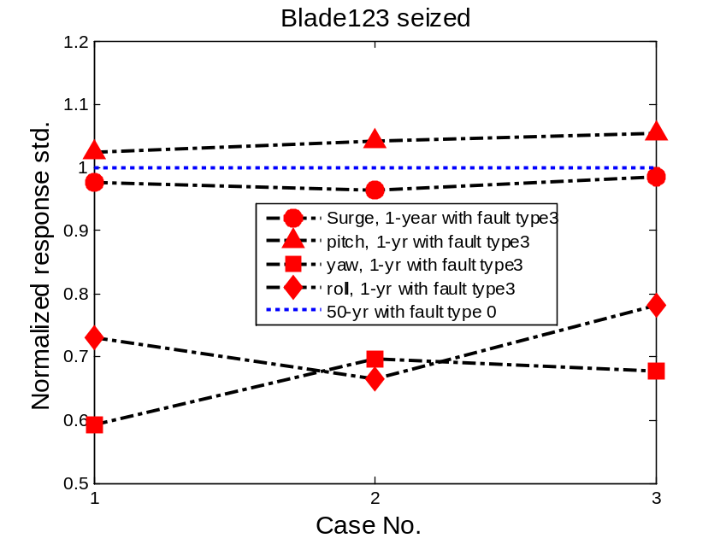
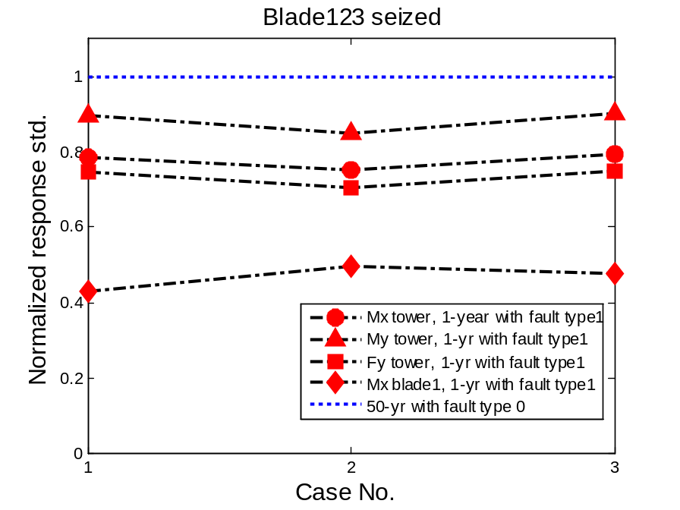
Comparison with 1-yr normal case
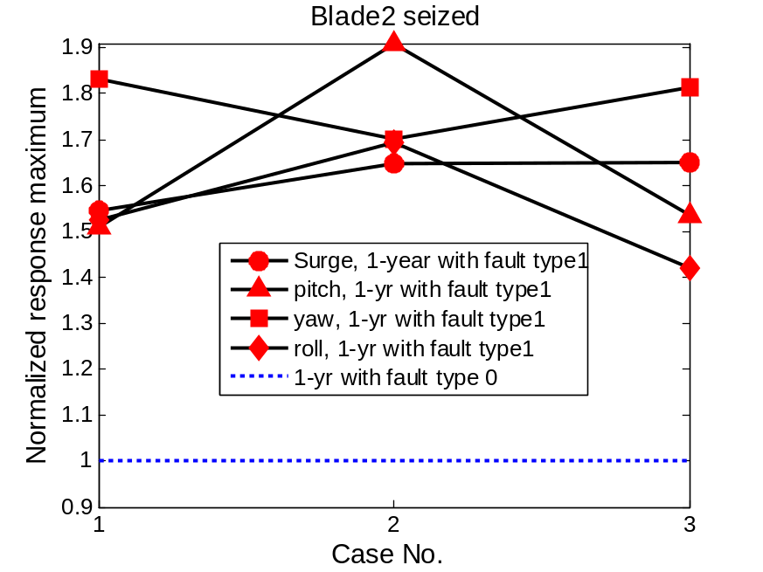
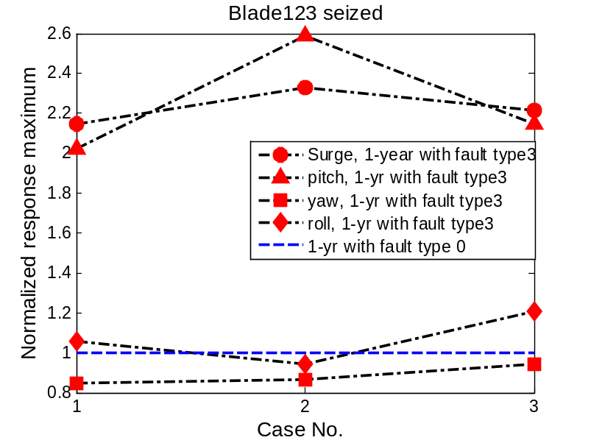
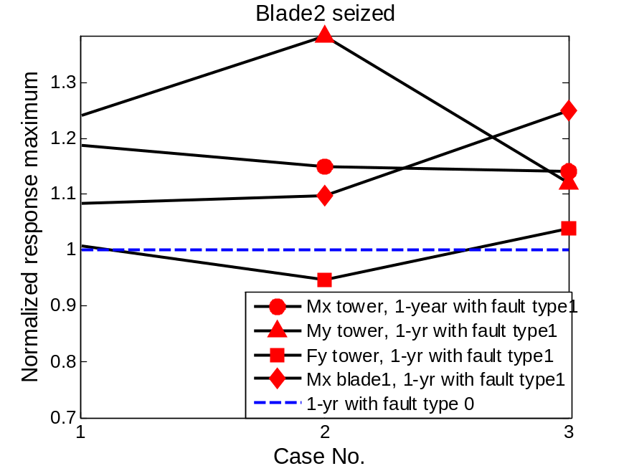

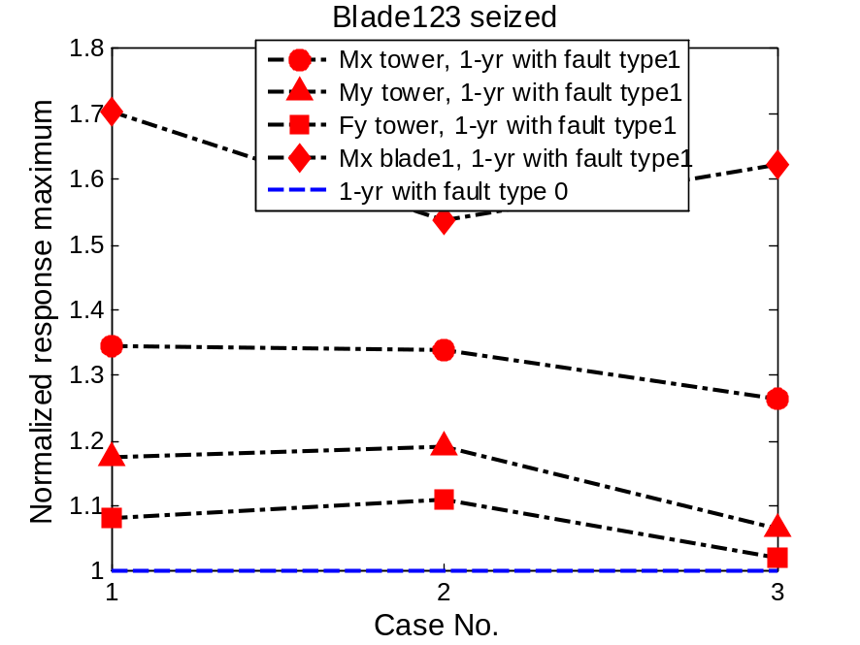
Std:
